WW2
PART ONE

T°BFI HG
Extended comprehension and synthesis assignment for week of 30 Sept – 4 Oct, to be completed for Homework, if necessary, and submitted on Tuesday 8th October. Please complete work on a separate sheet of paper. Look at the instructions on the more difficult tasks and the evaluation criteria to understand what is expected in your responses.

Read and use pages 53 – 56 to complete questions 1 through to 6:

1.Why did Henry Cabot Lodge not want the USA to ratify the Treaty of Versailles? Justify your response.

2.Although official neutral, what did Roosevelt ask Congress to modify in order to supply
arms to the UK in 1939?

3.What else did Roosevelt subsequently do in 1940 to enable Britain to obtain military equipment?

4.Explain what ‘lend-lease’ was and how it worked.

5. What was the strategic consequence of the sinking of the Reuben James?

6. To what extent did were US Pacific forces diminished by the 7 December attack on Pearl Harbor? What were the geopolitical repercussions during the following four days?

Read and use the Joint Statement on the following page to answer questions 7, 8 and 9:

7. What inspired this meeting between the US and Great Britain in the Atlantic?

8.What goals did the two nations set for future international diplomacy and the rights of nations?

9.Which mutual goals reflect the shared experience of the Great Depression and which reflect the shared experience of WW1? Justify your response.
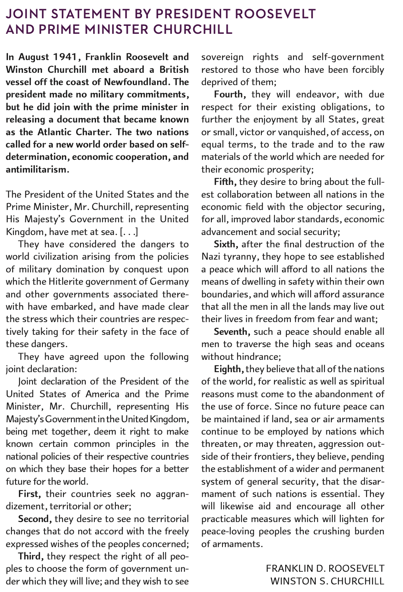
Read and use page 56 to complete question 10:

10. Summarize the economic impact (as a catalyst and burden) of WW2 on the US economy.

Refer to the information and poster below for questions 11 and 12:

11. The Americans and Japanese are represented by different animals in the WPA poster. What do these choices suggest about how people in the USA viewed the character of the two nations?

12. What event is Arthur Szyk depicting in the cartoon on the Collier’s cover? What evidence can you find in the cartoon to support your choice?
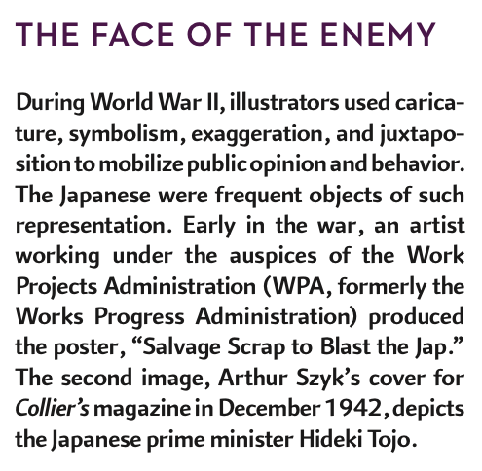

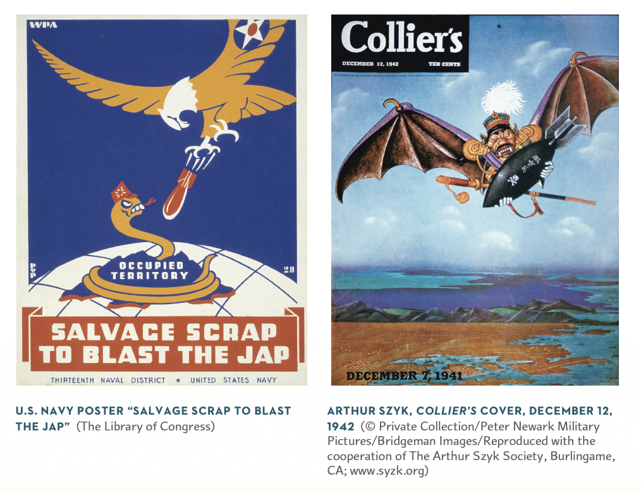
WW2
PART TWO
Read and use page 57-61

11. Produce a mind map entitled ‘The US Homefront’.

Concepts to incorporate into the mind map:
African Americans (C.O.R.E., ‘Freedom Rides’, Segregation in the army…),
Native Americans (‘code talkers’, ‘experience of capitalism, dwindling subsidies…)
Mexican Americans (braceros, tensions, ‘zoot suits’…)
Internment of Japanese Americans (racial animosity, internment, Korematsu decision…)
Sexuality (‘USO girls’, treatment of gay people, women in the workforce, factory/clerical work, juvenile crimes, ‘baby boom’).

T°BFI
WW2 SPECIAL INDIVIDUAL ASSIGNMENT
EVALUATION CRITERIA

EVALUATION CRITERIA | 0-8 | 9-12 | 13-16 | 17-18
PART ONE | Answers poorly written and copied closely from the text. Responses are unconvincing and reflect a poor level of understanding. | Answers simply written however reasons are given. Responses suggest a solid level of understanding. | Answers are well written. Student has used information from the text to develop coherent explanations in a good to very good level of English. | Answers synthesize (draw together) information from the booklet and demonstrate a sophisticated level of analysis.
GRADE FOR PART ONE

PART TWO | Very simple mind map, likely to consist of ‘chunks’ of text copied from booklet. | Reasonably clear mind map that shows impacts of war on US. | Well-constructed mind map that clearly explains the multi-faceted impact of WW2 on US homefront in student’s own words. | Mind map successfully uses information to give succinct explanations of the war’s impact and likely to be colour coded with a legend to aid readability.
GRADE FOR PART TWO

