DIRECTIONS:

- Write a well-organized essay that includes a strong introduction, body (topic and closing sentence for each paragraph), and conclusion that analyzes and interprets the assigned task
- Use the information from the documents and the answers to the questions in Part A (on next page) to support your response
- Do not simply repeat the contents of the documents
- Include details, examples or reasons to develop your ideas
- Utilize specific related outside information (your knowledge from lessons)

HISTORICAL CONTEXT:

After the Constitution was adopted by all of the States in 1789, uniting the States into one nation, differences between the States had been worked out through compromises. For more than 30 years arguments between the North and South had been growing. By 1861 these differences between the Northern States (which included the Mid-Western and Western States) and the Southern States had become so great that compromise would no longer work. Thus, a conflict started within our nation that was called the Civil War (1861-1865).

TASK PART B:

Most historians agree that the Civil War was caused by series of events and growing differences between the States. Write an essay in answer to this question: To what extent was slavery the leading cause of the Civil War?

PARAGRAPH | TOPIC
1 | Introduction—Outline the causes of the Civil War and end with a thesis statement in which you identify your argument (do not use first person personal pronouns).
2 | Reason #1 for secession; document support too
3 | Reason #2 for secession; document support too
4 | Reason #3 for secession; document support too
5 | Conclusion—Sum up what you have learned and explain if you think the South was justified (right)for leaving the United States

PART A - SHORT ANSWER QUESTIONS

DIRECTIONS: This task is based on the accompanying documents (1- 5). Some of these documents have been edited for the purpose of the task. The task is designed to test your ability to work with historical documents. As you analyze the documents, take into account both the source of the document and the author's point of view. For part A, look at each document and answer the questions after each document. For part B, use your answers to the questions to help write a well-organized essay.

DOCUMENT 1 - Compromise of 1850

- How were future new states to decide if they entered the Union as a free or slave state?

- What was the Fugitive Slave Law?

- How many slave states are there in 1850?

- How many free states are there in 1850?

- What evidence is there on the map to show a past compromise?

DOCUMENT 2 - Civil War Graphs

- Using the Population graph, which section of the country had almost twice the number of people living there? North or South?

- Using the Number of Soldiers graph, which section of the country had almost twice the number of soldiers in their army? North or South?

- Using the Number of Factories graph, what is the difference between the economies of the North and South?

- Using the Miles of Railroad Tracks graph, which section had a better railroad system to transport goods and supplies? North or South?

- Using all the graphs, list 3 reasons and explain why the North would do better in a war against the South.

- Explain why the information on this page is accurate or not accurate. Where could you look to verify the data?

DOCUMENT 3- Sectionalism (Differences between the North & South)

- Describe the economy of the South. How did the people make a living? What did they need for this type of economy?

- Describe the economy of the North. How did the people in North make a living? What did they need for this type of economy?

- What is the difference between the Northern and Southern economies?

DOCUMENT 4 - Slavery

- What did Harriet Beecher Stowe write about in Uncle Tom's Cabin?

- Did many people read Uncle Tom's Cabin? Explain your answer.

- What effect did Uncle Tom's Cabin have in the North? How did it make people feel about slavery?

DOCUMENT 5 - Lincoln's Election

- Using Lincoln's 1860 campaign poster, what did the Republican party support?

- What does the phrase "Free Territory" mean?

- What part of the country would vote for Lincoln? Why?

- Why would the election of Lincoln cause Southern states to leave the Union?

- What did the South mean by the phrase "state's rights"?

Document 1
Compromise of 1850

HISTORICAL BACKGROUND:

Until 1850, there were equal numbers of slave and free states in the United States. The Compromise of 1850 introduced into Congress by Henry Clay was designed to settle the slavery question arising from the new western lands acquired after the Mexican War. The Compromise gave some satisfaction to both the North and the South. The bill passed after it was divided into several parts: California enters the Union as a free state; Utah and New Mexico Territories are opened to slavery on the basis of popular sovereignty (i.e., territorial voters decide the issue); and the slave trade (but not slavery) is abolished in Washington D.C. It also included a strict fugitive slave law that required Northerners to return escaped slaves to their owners.

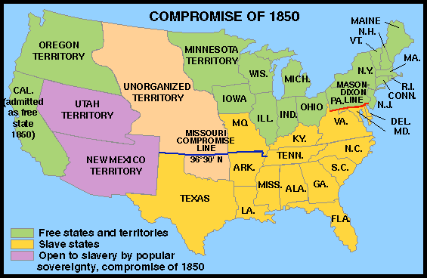

Source: Tindall's A Narrative History Gallery http://www.wwnorton.com/college/history/ushist/timeline/comp1850.htm

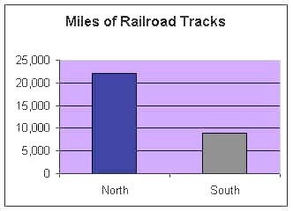
DOCUMENT 2
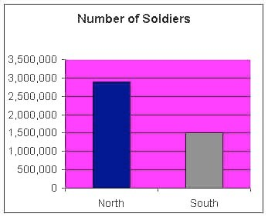
Civil War Graphs

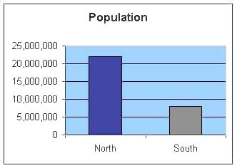

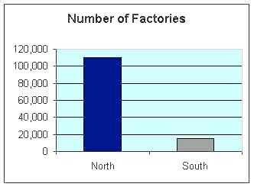

Sectional Differences

HISTORICAL BACKGROUND:

The sectional division between North and South began in colonial times and resulted from geographical differences. In the South, the earliest settlers found the warm climate and fertile soil ideal for growing tobacco. They started many tobacco plantations and brought in black slaves from Africa to provide most of the labor. In time, other plantation crops, especially cotton, sugar cane, and sugar beets, were found to thrive in the South. The South thus quickly established a rural way of life supported by an agricultural economy based on slave labor.

The cooler climate and rocky soil in the North were not suitable for establishing plantations or large farms. As a result of those and other factors, the North's economy came to depend more on trade than on agriculture. Industry and commerce were centered in the North. Many factories using mass-production methods had sprung up there, and cities grew rapidly." The North developed an intricate railway system and shipping industry to transport the manufactured goods.
Source: A-Z History http://school.discovery.com/homeworkhelp/worldbook/atozhistory/c/HEAD1

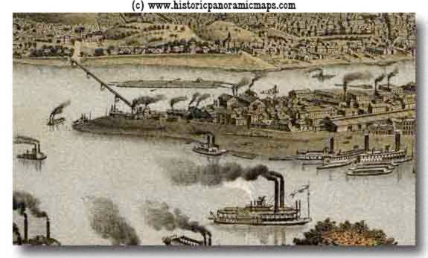
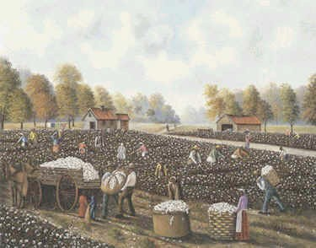

Southern Cotton Plantation 1850s Pittsburgh Factories 1850s

Slavery

HISTORICAL BACKGROUND:

Harriet Beecher Stowe published the best-selling antislavery novel, Uncle Tom's Cabin, in 1852. She wrote this book to show that slavery was evil and that the Fugitive Slave Law was unjust. Many Northerners viewed slavery as wrong. Abolitionists wanted to end slavery and some helped slaves escape to the North and Canada. The Southerner's believed that they were stealing their property.

Mrs. Webb's reading of Uncle Tom's Cabin was reviewed in Boston's The Liberator on December 15, 1855.

"Mrs. Webb read to an audience of 1300 persons. We trust that the story of 'Uncle Tom' may find access to thousands of hearts, and so hasten the day when the millions of whom he is the representative shall shake off the fetters (chains) of cruel bondage, and stand erect in the dignity of that freedom ."

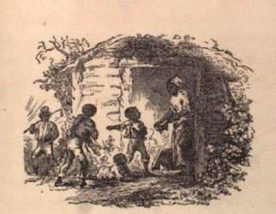

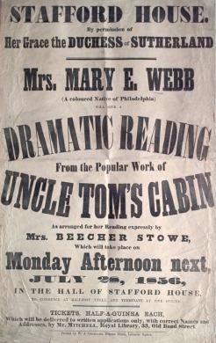
Uncle Tom's Cabin By Harriet Beecher Stowe Published in 1852

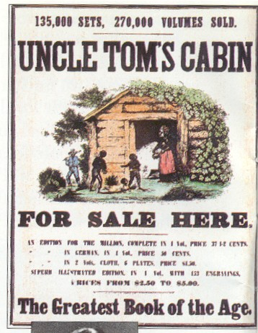

DOCUMENT 5
Lincoln Elected President

HISTORICAL BACKGROUND:

November 6, 1860 - Abraham Lincoln, who had declared "Government cannot endure permanently half slave, half free..." is elected president.

Dec 20, 1860 - South Carolina secedes from the Union. Followed within two months by Mississippi, Florida, Alabama, Georgia, Louisiana and Texas. Seven states of the Deep South, those in which the slavery system is most entrenched, leave the Union. Many Southerners favored secession as part of the idea that the states have rights and powers which the federal government cannot legally deny. The supporters of states' rights held that the national government was a league of independent states, any of which had the right to secede.

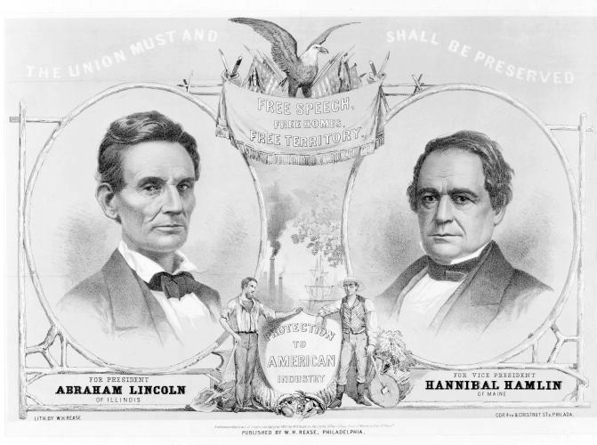

Source: American Political Prints, 1766 - 1876: A Catalog of the Collections in the Library of Congress, 1991, by Bernard F. Reilly, Jr.

