Actors and Production Spaces in the world

Map 1: The Impact of TNCs (Trans National Corporations)

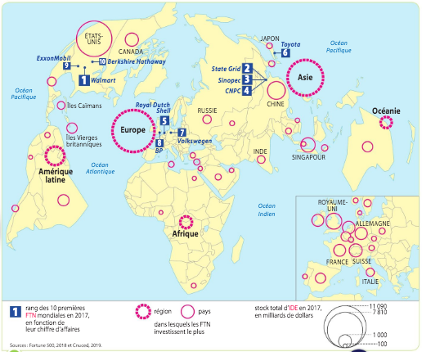

1 Rank of the top 10 global Region Country Total amount of FDI in 2017 in
TNCs in 2017, according to billons of dollars
turnover in which TNCs invest
the most

Map 2: Global concentration of R&D

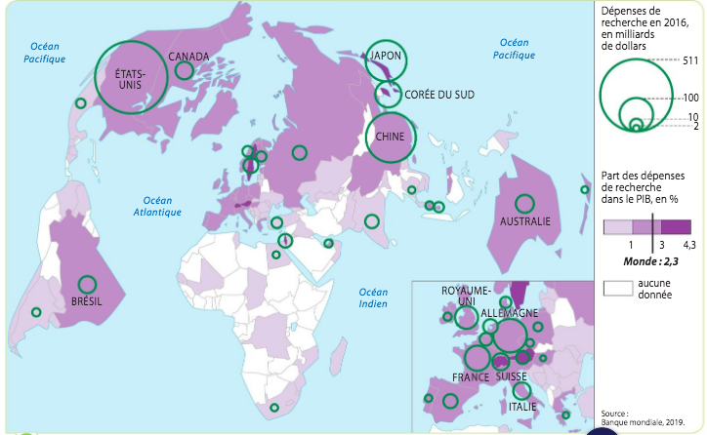
Spending on research and development in 2016, in billions of dollars
R&D spending as a proportion of GNP, in %
Map 3: Global Industrial Production Spaces

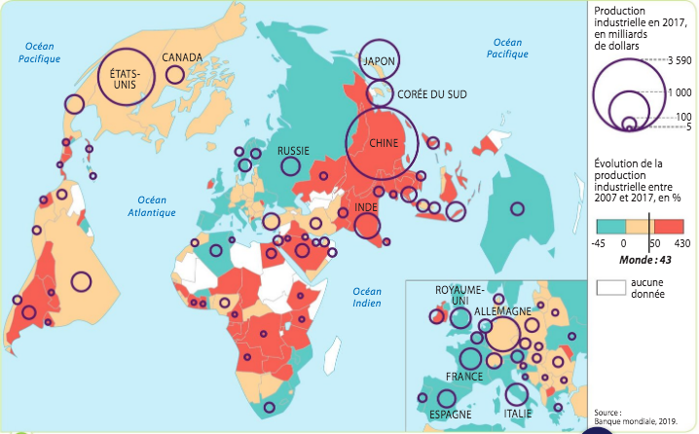
Industrial production in 2017, in billions of dollars
Evolution of industrial production between 2007 and 2017, in %
Exercises

1. Define TNC and FDI.

2. In which regions and what kinds of economies (LEDCs, MEDCs, BRICS) are the 10 principal TNCs located?

3. In which regions and what kinds of economies are R&D functions concentrated? Cite relevant examples.

4. Which regions have become centres of global production since 2007? What are the likely consequences on other countries?

5. Using these maps and your knowledge from class describe and explain the distribution of global production spaces in the world today.

