Case Study: Urban zone of Paris

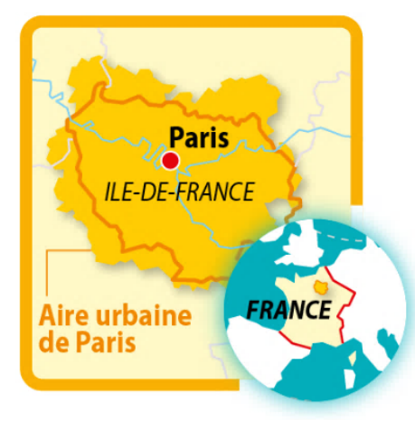
The urban zone of Paris (which includes the city centre and suburbs plus surrounding built up area) houses a population of more than 12.3 million people. It is the most populated area in France.

1. Place St Michel, situated in the historic city centre of Paris, surrounded by many apartments
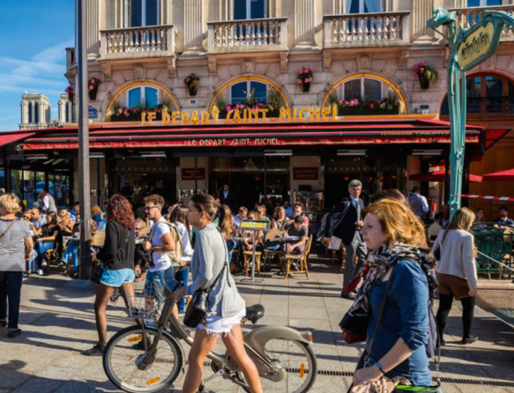

2. Louvres, a suburban commune of Paris

In less than 15 years, the town of Louvres (Val d’Oise) has nearly doubled in population. It is not far from Roissy and about 25km from Paris.

With the development of the Roissy transport platform over the last 10 years, the rate of job creation is 7 times more rapid than anywhere else in Ile-de-France. For every extra million passengers, 1 500 jobs are created.

Some have suggested that Louvres is becoming nothing more than a dormitory town (ville dortoir) for people who work at Roissy. Jean-Marie Fossier (Mayor of Louvre) admits this is the label used to describe many communities outside of Paris but as he says ‘in that case, all towns are really dormitory towns. The reality today is that most inhabitants of Ile-de-France work outside their town of residence.’

However, one major problem remains: transport. Louvres relies excessively on car usage.

3. Champdeuil, an outer suburb of Paris
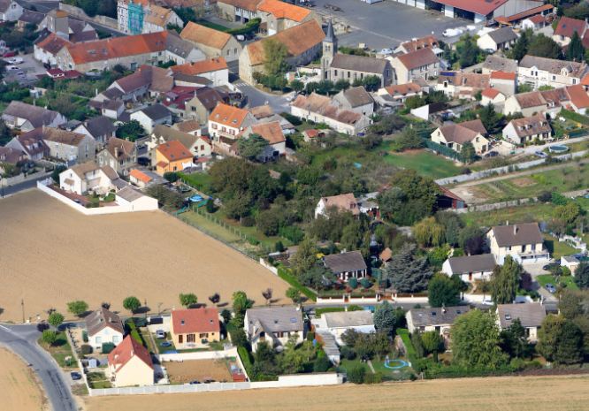
Located 55km to the east of Paris, Champdeuil extends outwards from a village centre and a church. It incorporates individual houses and housing estates (lotissements) in addition to companies and agricultural land.

4. The expectations of the inhabitants of Greater Paris

Greater Paris (Grand Paris) is a project to develop the surrounding urban area of Paris. It includes the creation of a new public transport network (réseau de transports en commun) to facilitate the daily commutes of the inhabitants in the city centre and the suburbs.

Case Study: Urban zone of Paris 2.

How does the Paris urban area contribute to the spread of French influence in the world today?

France is a globalised country today. Globalisation leads to political, economic and scientific competition between countries all over the world. In this context, the urban area of Paris is right at the heart of national territory.

5. Aeroville, a shopping centre at Roissy-Charles de Gaulle
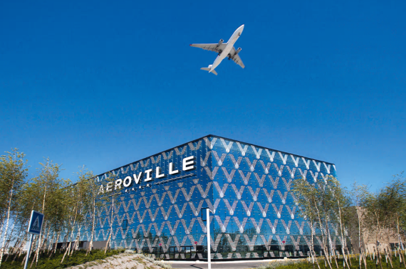
This shopping centre opened in October 2013 with the purpose of attracting some of the 63 million travellers who transit the airport annually. It comprises more than 200 shops, 30 restaurants and a cinema.

6. Welcome to La Défense!

Everything is done to make the installation of firms in the business quarter of La Défense as easy as possible. In terms of the number of headquarters (sièges sociaux) it is the biggest business park in Europe. The buildings are flexible in terms of usage and are continually being renovated so they meet the latest needs of businesses.

7. Map to show the different types of functions found in Paris

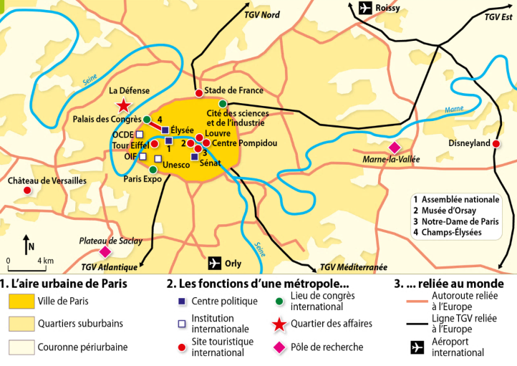

Translations
Urban area of Paris Functions of a capital city Links to the world

City of Paris Political function motorways connected
to Europe

Suburban quarters International institution High speed train line
connected to Europe
International tourist site

International Meeting Hall

Suburbanised periphery Business district
International airport
Research pole

