3° D.N.L. History-Geography Programme
HISTORY

Theme I: Europe, a Major Theatre of Total War (1914-45)
Chp1: Civilians and Soldiers in WW1
Chp2: Europe, Between Democratic and Totalitarian Regimes (1918-39)
Chp3: WW2, a War of Extermination
Chp4: France in WW2 (1940-44)

Theme II: The World Since 1945
Chp5: Independence and the Construction of New States
Chp6: A Bipolar World during the Cold War
Chp7: The European Project
Chp8: Issues and Conflict after 1989

Theme III: The French and the Republic Reconsidered
Chp9: Re-founding the Republic, 1944-47
Chp10: The 5th Republic of De Gaulle
Chp11: Women and Men in Society from the 50s to the 80s

GEOGRAPHY

Theme I: Territorial Dynamics of Contemporary France
Chp12: From Urban to Rural Spaces
Chp13: Productive Spaces and their Evolution
Chp14: Areas of Low Population Density and their Assets

Theme II: How and Why is the Territory Developing?
Chp15: Development in Response to Inequalities
Chp16: Development of Overseas French Territory

Theme II: France and the European Union
Chp17: The EU
Chp18: France and Europe in the World

E.M.C.

HISTOIRE
Thème I : L’Europe, un théâtre majeur des guerres totales (1914-1945)
Ch1 : Civils et militaires dans la Première Guerre mondiale
Chp2 : L’Europe, entre démocraties et régimes totalitaires (1918-1939)
Chp 3 : La 2e Guerre mondiale, une guerre d’anéantissement
Chp4 : La France dans la 2e Guerre mondiale (1940-1944)
Thème II : Le monde depuis 1945
Chp 5 : Indépendances et construction de nouveaux États
Chp 6 : Un monde bipolaire au temps de la guerre froide
Chp 7 : Affirmation et mise en œuvre du projet européen
Chp 8 : Enjeux et conflits dans le monde après 1989
Thème III : Françaises et Français dans une République repensée
Chp 9 : Refonder la République, 1944-47
Chp 10 : La Ve République, de la République gaullienne à l’alternance et la cohabitation
Chp 11 : Femmes et hommes dans la société des années 1950 aux années 1980
GÉOGRAPHIE
Thème I : Dynamiques territoriales de la France contemporaine
Chp 12 : Les aires urbaine en France
Chp 13 : Les espaces productifs et leurs évolutions
Chp 14 : Les espaces de faible densité et leurs atouts
Thème II : Pourquoi et comment aménager le territoire ?
Chp 15 : Aménager pour répondre aux inégalités
Chp 16 : Les territoires ultramarins français
Thème III : La France et l’Union européenne
Chp 17 : L’Union européenne, un nouveau territoire de référence et d’appartenance
Chp 18 : La France et l’Europe dans le monde

Enseignement Moral et Civique

The Brevet in History, Geography and Civic and Moral Education

Content of the Brevet
The exam lasts two hours and consists of three exercises.

Exercise 1: This is based on one or two History or Geography documents (text, photograph, map..) and you must write responses to questions using the documents.

Exercise 2: You must respond to a longer Geography or History question. You may also need to draw a sketch or chronology.

Exercise 3: This consists of a problematic from Civic and Moral Education. You will have to respond to one or more questions using one or two documents.

DNB
Pour les candidats scolaires, l'obtention du diplôme national du brevet (DNB) est liée à la maîtrise du socle commun de connaissances, de compétences et de culture et aux résultats obtenus aux épreuves d'un examen terminal.

Histoire, Géographie and Moral and Civic Education (2 heures)

Exercice 1. Analyser et comprendre des documents (20 pts)

Exercice 2. Maîtriser différents langages pour raisonner et se repérer (20 pts)

Exercice 3. Enseignement moral et civique (10 pts)

Useful Linking Words and Prepositions

although pourtant
as en tant que
despite malgré
even if même si
even though quand même
however cependant
nevertheless néanmoins
then, so, hence alors
thus ainsi
since puisque
when lorsque
whereas tandis que
while alors que

French Preposition | Common English Equivalent
A | at, in
Après | After
Avant | Before
Avec | With
Chez | at/to ...'s house/place
Contre | Against
Dans | in(side)
De | of, from
Depuis | since, from
Derrière | Behind
Devant | in front of, outside (the front of)
En | In
Entre | between, among
Envers | Towards
Environ | about, approximately
Par | by, through
Pendant | During
Pour | For
Sans | Without
Sauf | Except
Selon | according to, depending on
Sous | under(neath)
Sur | On
Vers | Towards
Useful Vocabulary for History and Geography
PIE CHART LINE GRAPH BAR GRAPH TABLE
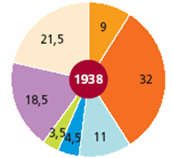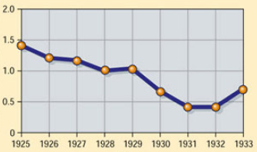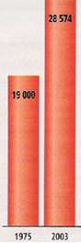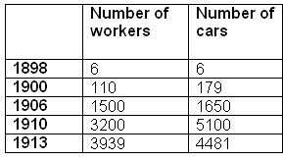
Words used to describe a graph :
Increase Decrease
Rise Descend
Incline Drop
Steep increase Sharp drop
Gentle increase Gradual decrease

Numbers and Years
100 = one hundred 1987 = nineteen eighty seven
1 000 = one thousand 1759 = seventeen fifty nine
10 000 = ten thousand 2018 = two thousand and eighteen
100 000 = one hundred thousand
1 000 000 = one million
1 000 000 000 = one billion

Compass Directions
In the east in the eastern regions
In the south in the southern part of the country

North
West East
South

Maps
Maps may be drawn in colours such as red, green and blue or they might be presented in shades of black and white.

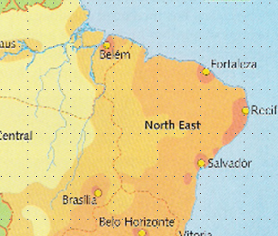
For example this map of Brazil uses darker shades to show that more people live near the coast and lighter shades away from the coast to show where fewer people live.
Photographs
Background of the photo
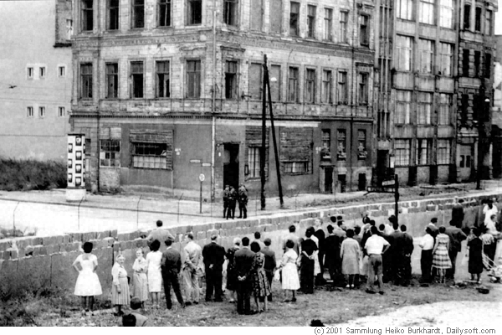
Foreground of the photo

