1930s fascism in the UK
There were angry scenes when Sir Oswald Mosley led a fascist march through the heart of London in October 1936
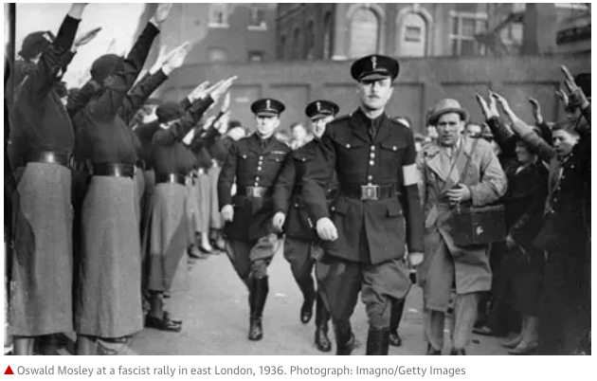

Riots in London: Guardian report, 1936

The fascists marched in London yesterday – but away from the East End, not through it. Their proposed procession through the heart of the Jewish quarter – which had caused strong protests to be made to the home secretary and had created a tense situation in the East End – was stopped by the police when it was on the point of setting out, and it went, instead, along the Embankment.

Prior to the arrival of Sir Oswald Mosley, disorder broke out among those who had collected to oppose the fascist marches, and resulted in a number of arrests. In view of the very large crowds, the commissioner of the police for the metropolis decided that the procession through the East End should not be permitted owing to the great likelihood of further breaches of the peace. The fascists' procession, therefore, was escorted by the police along the Embankment to the Temple station, where it dispersed.
Advertisement

Councillor Roberts, mayor of Stepney, told a reporter that she had never seen the people of the East End so thoroughly roused and angry. Every avenue to the Aldgate was blocked by huge crowds of people – Christian and Jew. "I understand," she said, "that many people have been hurt, and I cannot but think that all this could have been avoided had the Home Office and the commissioner of the police done before the march what they were compelled to do during the march.

Sir Oswald Mosley, who usually appears hatless and wearing a black shirt and leather waist-belt, wore the new fascist uniform yesterday – a black, military-cut jacket, grey riding breeches and jackboots. He had a black peaked military hat and a red arm band. Many of the fascists on parade wore a similar uniform.
Manchester Guardian, 5 October 1936

https://www.theguardian.com/world/2009/sep/05/uk-fascism-oswald-mosley

Fact file

Sir Oswald Ernald Mosley (1896-1980), 6th Baronet was a British politician who rose to fame in the 1920s as a Member of Parliament and later in the 1930s, having become disillusioned with mainstream politics, became leader of the British Union of Fascists from 1932 to 1940 and of its successor, the Union Movement, from 1948 until his death. Those groups were known for distributing anti-Semitic propaganda, conducting hostile demonstrations in the Jewish sections of East London, and wearing Nazi-style uniforms and insignia.

