History-Geography Obligatory Summer Prior Reading and Homework for students entering T°OIB in September 2021

HG OIB is assessed via a 4 hour written exam and a 20-minute oral exam. To have the best preparation possible for this demanding syllabus you must begin the prior reading over the summer as part of your summer homework using the books identified below:

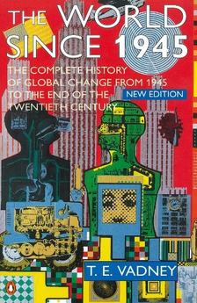

This is the core text for T°OIB History:

Students are expected to read the chapters identified on the pages overleaf in preparation for History lessons.

The World Since 1945: A Complete History of Global Change from 1945 to the Present (English Edition) by T. E. Vadney

ISBN 978-0-14-026875-1

This is the core text for T°OIB Geography:

Students are expected to read the chapters identified on the pages overleaf in preparation for Geography lessons.

Prisoners of Geography: Ten Maps That Tell You Everything You Need To Know About Global Politics (English Edition) by Tim Marshall

ISBN-978-1-78396-243-3

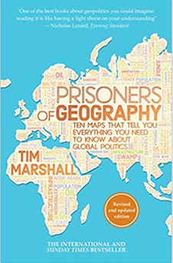

Please note: A pdf version of Prisoners of Geography is available for download on the T°OIB Google Drive so it is not necessary to buy this book – however it is easier to have the book than to print out everything from the pdf document.

T°OIB Obligatory Prior Reading

History-Geography OIB Syllabus

The T°OIB programme covers a vast range of content so it is essential to complete all obligatory reading in order to be ready for the written and oral exams.

History

Theme 1: Challenges to Democracy, Rise of Totalitarianism and World War II: 1929-1945
Reading:
VADNEY
CHP1 ORIGINS OF POST WAR WORLD
Chp1: Causes and impacts of the 1929 Crisis + Great Depression
Chp2: Totalitarian Regimes (Nazi Germany and Stalin’s USSR)
Chp3: World War Two (Survey of the war, Violence, French Experience)

Theme 2: The Post War Bi-Polar World and Challenges

Reading: VADNEY

CHP2 THE USA +
CHP3 THE THIRD WORLD
Chp1: End of WW2 and Emergence of the Cold War

Chp2: A New Geopolitical Order and Emergence of the Developing World

Reading: VADNEY
CHP4 +
CHP6 pgs 226-232 (Algeria) +
CHP7 pgs 282-300 (Cuba) +
CHP 8
a) Creation of Israel and the Arab Response *
b) Emergence of Mao’s China *
c) Vietnam War, 1955-63
d) French Republic and Nationalist
Movements in Africa, 1954-62
e) Castro’s Cuba, 1959-62 *

Theme 3: Economic, Political and Social Changes: 1950s-91

Chp1: International Economic and Political Changes
Reading: VADNEY

CHP10 THE DEVELOPED CENTRE

and

CHP11 THE END OF THE TWENTHIETH CENTURY

a) Oil and Political Islam
b) Deng and Reagan
c) The Rise of the EU and Fall of the USSR

Chp2: Domestic Challenges within the USA
and France from the 1950s to 2001

Pillar One: The USA

Impact of Vietnam War
Civil Rights Movement
Rise and Evolution of Conservatism

Pillar Two: Protest and Government
Responses in the USA and France

1968 and Counterculture
Feminism and Women’s Rights
LGBTQ+ Rights

Geography

Theme 1: Seas and Oceans at the Core of Globalization
Reading:
MARSHALL
CHP 2 CHINA +

CHP3 THE USA

-Importance of Maritime Space in globalization
-Unequal integration of territories into globalization
-Tensions between States over the control and use of maritime space (e.g. South China Sea)

-Question spécifique: France and the USA – a comparison of maritime powers

Theme 2: Territorial Dynamics, Cooperation and Tensions in Globalization

-Unequal integration of territories into globalization
Reading:
MARSHALL
CHP 1 RUSSIA +
CHP3 THE USA +
CHP9 LATIN AMERICA

-The place of the USA in Globalization
-Examples of Globalization at different scales:
Local, Regional, Global

Question spécifique: France – differentiated
international influence and unequal attractiveness in globalization

Theme 3: Complex Dynamics: The European Union and Globalization

- The European Union and Globalization
Reading:
MARSHALL
CHP3 THE USA +
CHP4 WESTERN EUROPE

Question Spécifique - The differential dynamics
of cross- border territories of the United States
and of France in the EU.

To learn more the events, places and people you encounter during your reading, all OIB students have access to the Britannica website which is kept up-to-date and safe. Here is the access code:

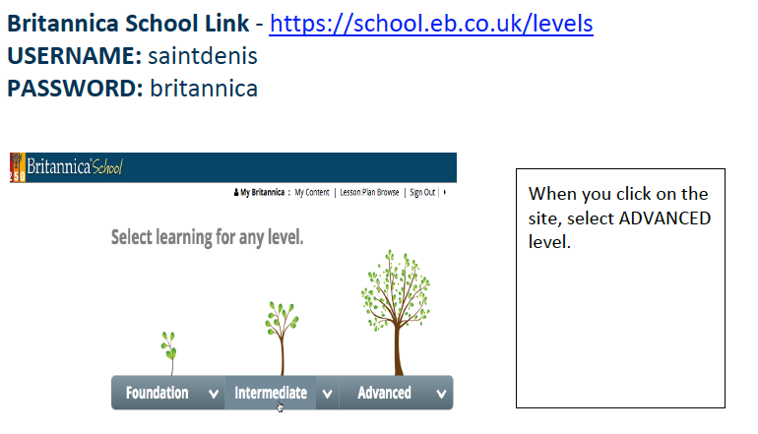

2021 Summer work assignment

- Buy the two books (or download Prisoners of Geography) and read the chapters and pages specified for each book on the preceding pages for HISTORY THEME 1 and GEOGRAPHY THEME 1.

- Read and carefully examine American Republic Chapter 17, The Great Depression Begins, 1929-32, then:

  - Complete Section 1 Assessment exercises 1- 8 (around 250 words expected for final question).

  - Complete Section 2 Assessment exercises 1-8 (around 250 words expected for final question).

- Pay particular attention when reading Prisoners of Geography Chapter on China and Chapter on the USA because there will be a multiple choice test on these chapters in the autumn.

- Please send work to twebb@ent-saint-denis.net no later than Friday 20th August.

