History-Geography Obligatory Summer Prior Reading and Homework for students entering 1°OIB in September 2021

HG OIB is assessed via a 4 hour written exam and a 20-minute oral exam. To have the best preparation possible for this demanding syllabus you must begin the prior reading over the summer as part of your summer homework using the book identified below:

This is the core text for 1°OIB and T°OIB Geography:

Students are expected to read the chapters on the USA, Europe and China in preparation for Geography lessons.

Prisoners of Geography: Ten Maps That Tell You Everything You Need To Know About Global Politics (English Edition) by Tim Marshall: ISBN-978-1-78396-243-3

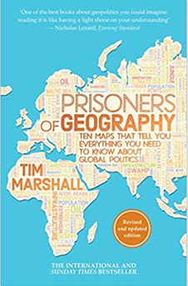

Please note: A pdf version of Prisoners of Geography is available for download on the 1°OIB Google Drive so it is not necessary to buy this book – however it is easier to have the book than to print out everything from the pdf document.

To learn more the events, places and people you encounter during your reading and lessons all OIB students have access to the Britannica website which is kept up-to-date and safe. Here is the access code:

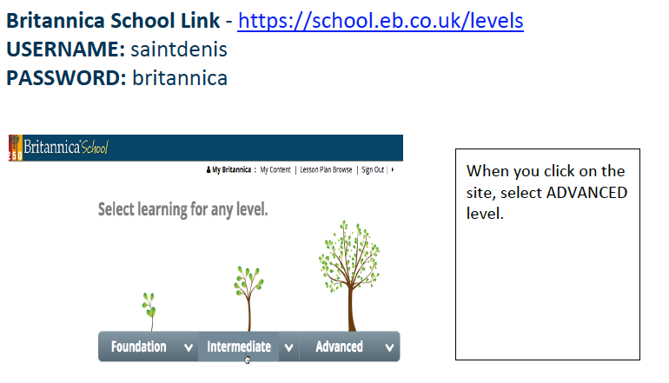

2021 Summer work assignment

- Buy the book (or download it – but you will use it over two years) and read the chapters on the USA, Europe and China.

- Read and carefully examine American Republic Chapter 12, Manifest Destiny, then:

  - Complete Section 1 Assessment exercises 1- 6.

  - Complete Section 2 Assessment exercises 1-6.

- Please send work to twebb@ent-saint-denis.net no later than Friday 20th August.

