T°EURO - Theme 2: The European Construction in the Context of the Cold War and a Multi-polar World
The Multi-Polar World

Superpowers are states or organisations with a dominant position in the international system. They have the ability to exert or influence events in their own interest and project power on a worldwide scale to protect these interests.

The term ‘superpower’ was first used by T.R. Fox in 1944 in his book which examined the role of the USA, UK and the Soviet Union. Superpowers primarily have economic and military power. Emerging superpowers, such as India and Brazil, have power based on their increasing economic importance and resources. Regional powers, such as Germany, have a continental influence rather than a global reach. Only the USA is truly still a superpower today due to its vast economic and military power and cultural influence. However, this could change as other countries challenge the USA in terms of power and influence such as China or the European Union.

Power can be maintained using soft power through the spread of culture and ideology. For this, media is vital for promoting the beliefs and messages of superpowers. The current global superpower, America, uses soft power to maintain a global influence through ‘McDonaldisation’ and ‘Americanisation’. Soft power, though not violent, causes the erosion of traditional cultures and ideologies. Hard power involves military action which is the most threatening mechanism. The USA has a military presence on every continent apart from Antarctica, with the NATO membership strengthening its military. This type of power can be seen as aggressive and hostile whilst inviting violence globally but it protects the superpower. A multi-polar world involves three or more superpowers; a phenomenon that has been evolving since 2010 with the rise of the EU, China and the USA.

Document 1: Measuring Power

The world’s most powerful countries also are the ones that consistently dominate news headlines, preoccupy policymakers and shape global economic patterns. Their foreign policies and military budgets are tracked religiously. When they make a pledge, at least some in the international community trust they will keep it.

The 2020 Best Countries rankings formed in partnership with BAV Group, a unit of global marketing communications company VMLY&R, and the Wharton School of the University of Pennsylvania, are based on a survey that asked more than 20,000 people from four regions to associate 73 countries with specific attributes.

The Power subranking is based on an equally weighted average of scores from five country attributes that related to a country's power: a leader, economically influential, politically influential, strong international alliances and strong military. The Power subranking score had an 8% weight in the overall Best Countries ranking.

There was no change this year in the top 10 countries seen as being the most powerful, though two of them shuffled positions. The United States, which is perceived to be the most powerful country, has the world’s largest economy and biggest military budget, spending over $649 billion on military hardware and personnel in 2018. The country is a leader in the so-called War on Terror, is by far the largest contributor to NATO and cements alliances by giving out billions of dollars in military aid to nations worldwide. The U.S. spent slightly more than $35 billion in economic aid and nearly $15 billion in military aid in 2017, the most recent year data is available.

Russia and China, the next two countries perceived to be the most powerful, are among the world’s top four military spenders. Following the top three are Germany, the U.K., France and Japan – countries that have large economies and give out high amounts of international aid. Israel, which take the eighth spot, spends a higher percentage of its GDP on military spending than the U.S., South Korea and Saudi Arabia traded positions this year, ranking No. 9 and No. 10, respectively.

Countries perceived to be less powerful tended to be smaller nations with medium to small economies. Slovenia, a small country in Southeastern Europe, is viewed as the least powerful nation. Baltic countries Estonia, Latvia, and Lithuania and Central Europe’s Slovakia round out the bottom five.

Countries with United States military bases and facilities as the United States still remains the leading example of superpower military projection.

The Belt and Road Initiative known as One Belt One Road or OBOR for short, is a global infrastructure development strategy adopted by the Chinese government in 2013 to invest in nearly 70 countries and international organizations. "Belt" is short for the "Silk Road Economic Belt," referring to the proposed overland routes for road and rail transportation through landlocked Central Asia along the famed historical trade routes of the Western Regions; whereas "road" is short for the "21st Century Maritime Silk Road", referring to the Indo-Pacific sea routes through Southeast Asia to South Asia, the Middle East and Africa.

https://www.usnews.com/news/best-countries/power-rankings

Document 2: The 2017 results of the International Comparison Program:
China, US and EU are the largest economies in the world

In 2017, the Gross Domestic Product (GDP) of the European Union with 27Member States (EU) represented 16.0% of world GDP, expressed in Purchasing Power Standards (PPS). China and the United States were the two largest economies, with shares of 16.4%and 16.3% respectively. Other countries (outside the EU) with a share larger than 1% are shown in the visual below.

The European Union of 27 Member States (EU) includes Belgium, Bulgaria, Czechia, Denmark, Germany, Estonia, Ireland, Greece, Spain, France, Croatia, Italy, Cyprus, Latvia, Lithuania, Luxembourg, Hungary, Malta, the Netherlands, Austria, Poland, Portugal, Romania, Slovenia, Slovakia, Finland and Sweden. As of 1 February 2020, the United Kingdom is no longer part of the European Union.

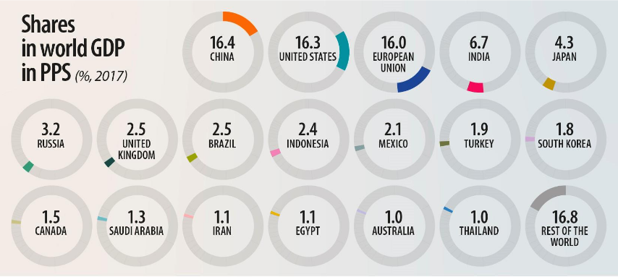

While the US and China are about the same size in terms of GDP in PPS, their respective GDP per capita differs by a factor of four, as shown below.

The Purchasing Power Standard (PPS) is an artificial currency unit that eliminates price level differences between countries. Thus, one PPS buys the same volume of goods and services in all countries. This unit allows meaningful volume comparisons of economic indicators across countries and shows which are the largest economies.

https://ec.europa.eu/eurostat/documents/2995521/10868691/2-19052020-BP-EN.pdf/bb14f7f9-fc26-8aa1-60d4-7c2b509dda8e

Exercise

Using your knowledge from this document, the PowerPoint and the videos (see blog) write a response to this question in around 15-20 lines:

To what extent are we living in a multi-polar world?

