The Multi-Polar World
Instruction: Take notes from the PowerPoint

Defining a multi-power world

What does this map show?
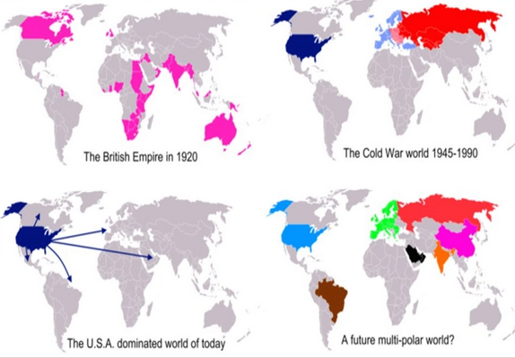

How is power measured?

2020 World Power Rankings

Top Six countries (population and GDP)

Explain what this map demonstrates about prevailing US global influence

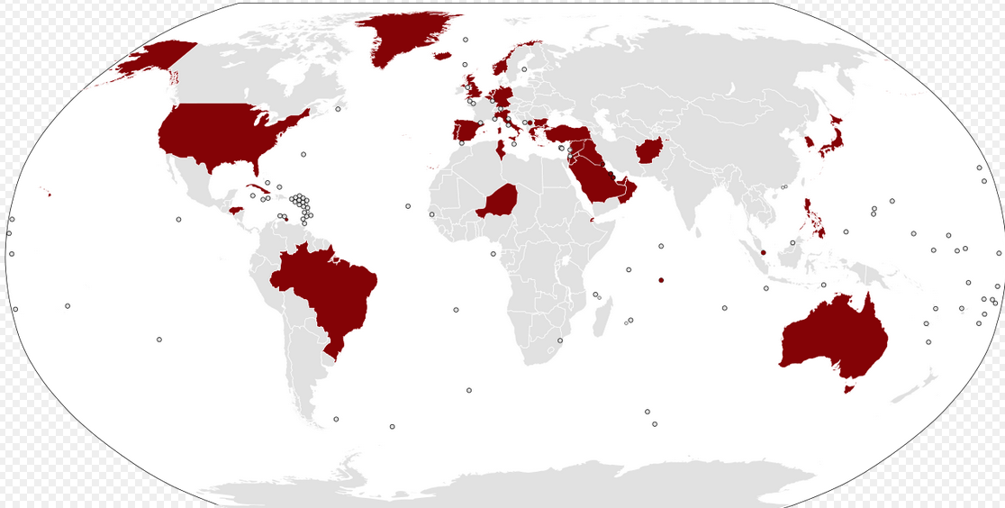

What does this map show?

