India’s Path to Economic Development

India is one of the BRIC economies (Brazil, Russia, India and China), forecast in 2001 by the Head of Global Economic Research at Goldman Sachs to become the next big four global economies. China’s global manufacturing success in the last 20 years is well documented, Brazil has become the driver of industrial expansion in South America and Russia’s oil and gas-driven geopolitical power has had a profound effect on energy security in Eurasia.
India has taken a different path to economic development. It has ‘leapfrogged’ large-scale industrialisation and instead drawn upon its highly skilled, IT literate, English-speaking workforce. India has driven the globalisation of services since the late 1980s and looks set to continue to develop in the tertiary and quaternary sectors

The Indian software and services export sector has grown rapidly since the early 1990s and today employs more than a million professionals. The sector has become a major export earner for India and has maintained momentum throughout the 2000s, consolidating partnerships with overseas customers. Early partners in outsourced call centres and other administrative functions included British Airways and American Express and now includes Aviva, Accenture, Dell and Lloyds TSB. Many early call centres were located in New Delhi, although Bangalore, Chennai and Mumbai have since emerged as major centres in this sector. The Business Process Outsourcing(BPO) sector is the fastest growing segment within India’s software services sector with many back-office functions such as customer care and finance administration being performed for western TNCs (Trans National Corporations). Approximately 60% of global offshore BPO takes place in India.
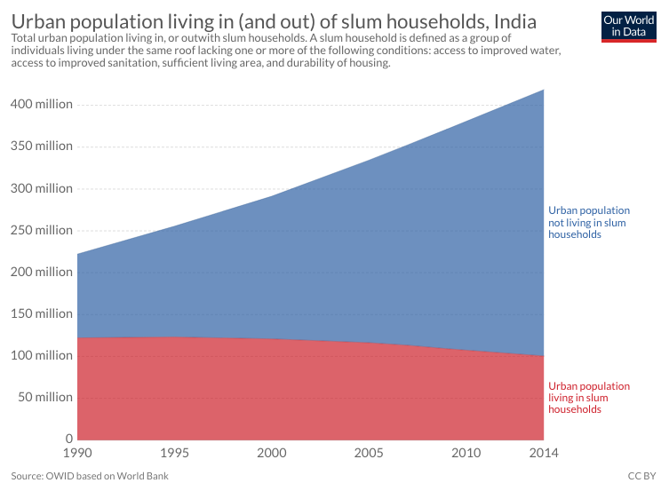
https://www.tutor2u.net/geography/reference/indias-path-to-economic-development

