How Is Japan Dealing With Its Rapidly Ageing Population?

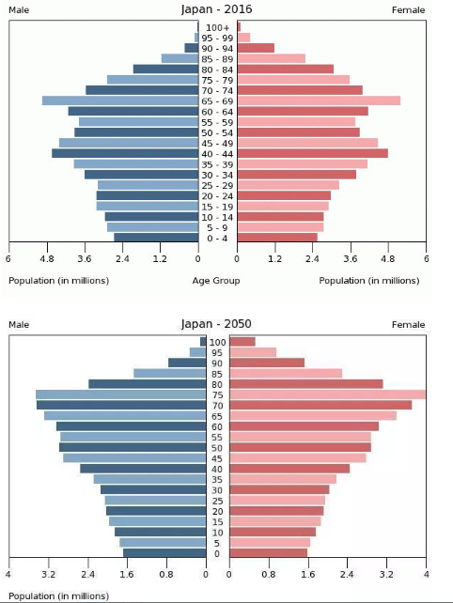

Why is this happening?
Excluding Monaco, Japan has the highest life expectancy of any country in the world – 83.7, and a very low fertility rate of 1.45. However, these figures are not too dissimilar from some European countries, so what really explains Japan’s declining population is it low immigration rate – only 1.8% of Japanese are foreign, compared to 8.6% in the UK for example!

What will the consequences be:
Nicholas Eberstadt argues that we already seeing some of the consequences:
- Labour shortages, especially in care work, hospitality, construction and agriculture.
- 400 school closures a year.
- The emergence of ‘ghost towns’ as the population decreases
- Increased burden on elderly welfare – by 2060 36% of its population will be 65 or older.

Why is the Fertility Rate so Low?
It’s basically a combination of two factors:
- Economic problems – 50% of the population are in precarious jobs, and economic insecurity is a key reason for not having children. Also, if couples were in a position to have children childcare is too expensive for both partners to remain in work, so this may scupper the desires of even those in permanent jobs!
- Traditional gender values remain intact – Japan is the 114th most gender unequal country in the world – traditional and patriarchal values remain in-tact – women don’t want children out of wedlock or with men with no economic prospects – which is about half of all men in Japan.

Why is Migration so Low?
Japan is geographically remote and culturally homogeneous. Japan has long discouraged immigration – they see it as a threat to Japans’s culture and low crime rate – in fact they point to migration across Europe as an example of its negative impacts.
How is the government going to tackle the crisis?
There are a range of measures…
- Government sponsored ‘speed dating’ services.
- By providing longer maternity leave and childcare
- To offset the shrinking labour force through a ‘robot revolution’.

Is there an Upside?
Well, there’s more land per head, and because Japan is the first to transition into what will likely become a global trend, it’s an opportunity for it to become a world leader in technologies that can assist an ageing population.

Sources:
Adapted from The Week 2nd December 2017.
https://revisesociology.com/2018/01/11/japan-ageing-population/

