Geography
Theme II: Spaces of Low Population Density

Chapter 4: Living in an Agricultural Space

One out of every two people in the world live in the countryside. In Asia and Africa, 60% of the population depend on agriculture for their livelihoods.

In developing countries, most of the population live in the countryside whereas in the developed countries, most inhabitants live in urban areas.

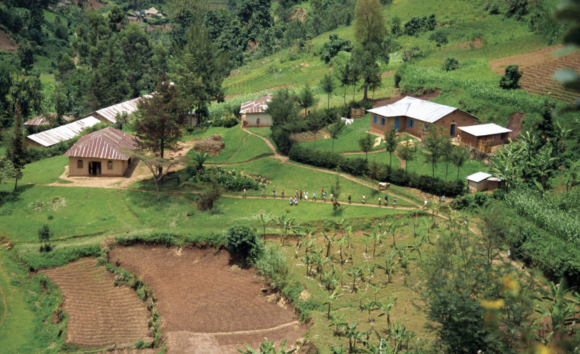

The village of Kabale in Uganda.
Most of the inhabitants are peasants and the agricultural space is organised into parcels of land divided by the natural slopes of the valley. The humid climate allows residents to cultivate cereals, potatoes & maize.

In the developed countries, agriculture is mainly commercial agriculture. There are not many farmers but they are able to produce lots of harvest due to mechanised intensive agriculture. Farms are often diversified with holiday cottages (gites) and camp sites providing a complementary revenue.

However, in developing countries, agriculture is often subsistence in character. This means it is destined to feed the family and yields are often quite low.
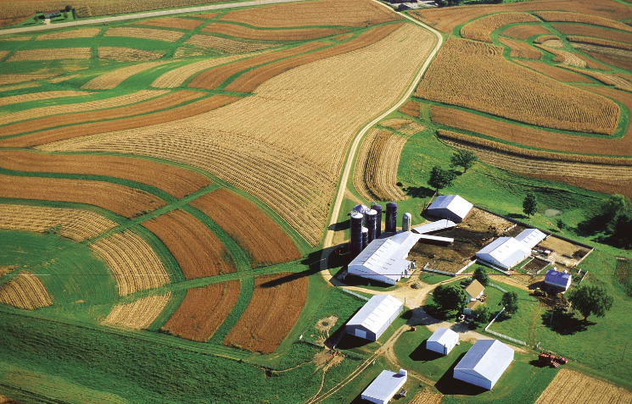

A farm in Wisconsin, USA.
The state of Wisconsin is one of the principal agricultural regions of the USA. On the Great Plains, agriculture is very productive and highly mechanised.

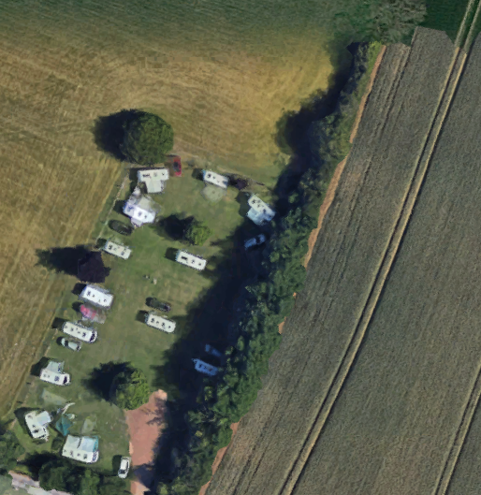

Diversified agriculture in the Midlands, UK.
This farm has opened a caravan site in one of the fields to provide an additional revenue for the farm.
Different types of agriculture in the world

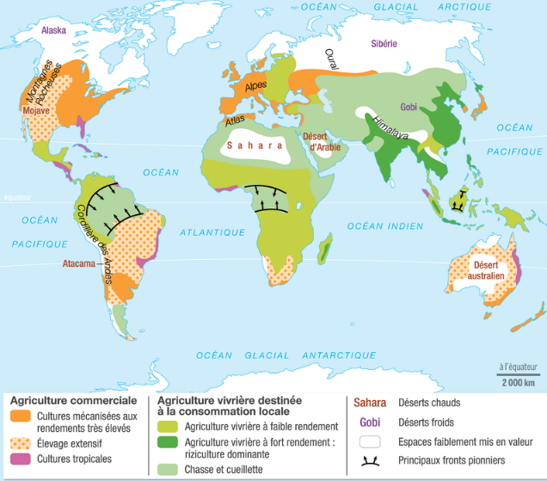

Translations
Commercial agriculture Subsistence farming Sahara Hot deserts
Mechanised farming with Low yield subsistence farming Gobi Cold deserts
high yields High yield subsistence farming: Minimally used spaces
Extensive grazing (predominantly rice) Principal pioneering fronts
Tropical agriculture Hunting and gathering

