Background to World War One

Document 1 The Alliance System:

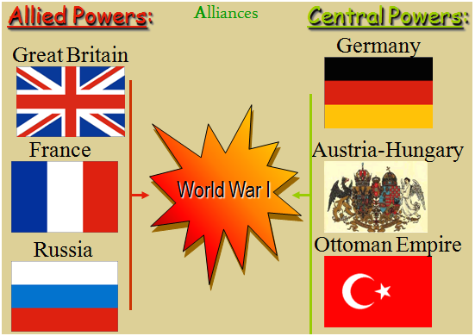

Document 2 Europe: the Powder Keg (long term and short term causes of WW1):

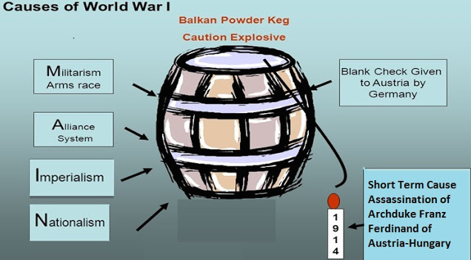

Document 3 Photograph of the Dreadnought:

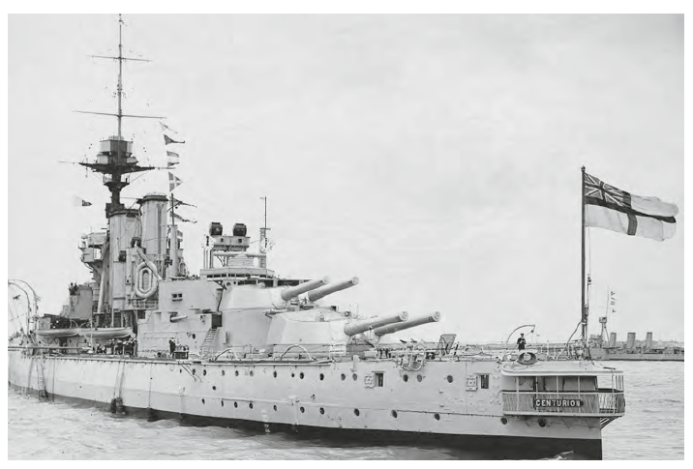

A British Dreadnought class battleship, launched in 1906. The name Dreadnought literally meant ‘feared nothing’. This ship had a superior range and firepower compared to any other ship and led to a naval race from 1906 onwards as Britain and Germany each tried to build as many dreadnoughts as possible. This naval race was one of the causes of WW1.

Document 4: Table of European Powers Compared, 1900

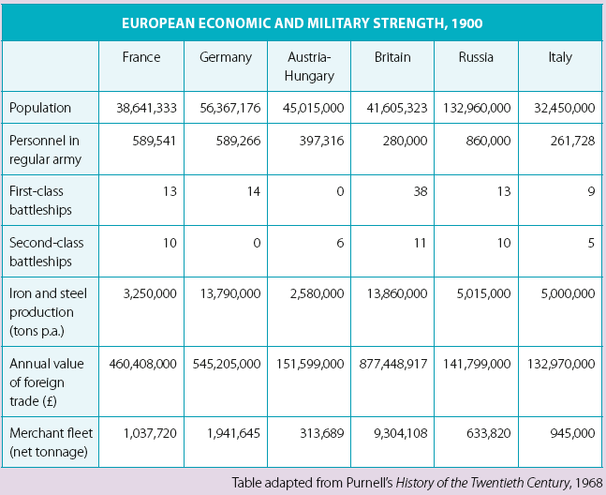
Exercises to complete using the documents

Objective: to learn some of about the causes of WW1, build up your vocabulary and be able to coherently use documents to describe and explain your ideas in English.

1. What kind of documents are documents 3 and 4? 1pt

2. Using documents 2 and 3, plus your own knowledge, explain what the alliance system was. 2pts

3. Explain what the ‘Blank check’ (spelt ‘cheque’ in UK English) given to Austria by Germany meant. 4pts

4. Justify use of the name ‘dreadnought’ for the new class of battleship launched in 1906? 2pts

5. Use document 4.

a) Which categories are important for indicating the strength of a country in war? Give reasons for your response. 4pts

b) Which alliance system seems to be the strongest? Give reasons for your response. 4pts

Up to 3 points
for presentation and correct use of English + sophistication of written expression.

/20

