Chapter 6: France, Productive Systems – Local, European and Global

1. What does each of the two photographs below show? What economic changes/processes do they reflect?
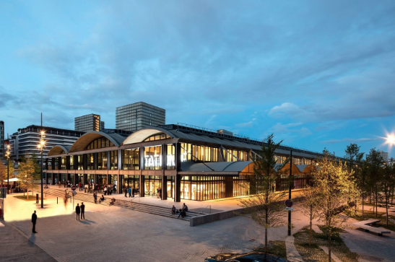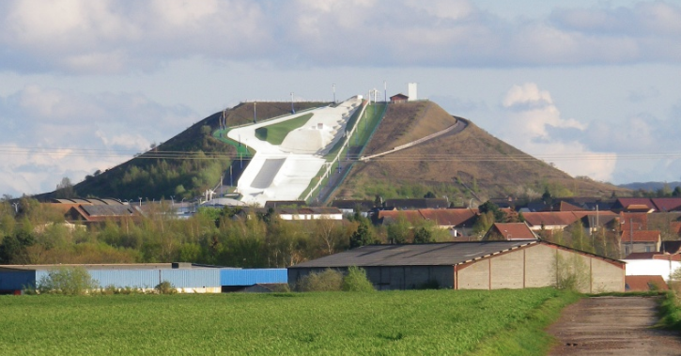

2. With the aid of the document below, compare the economic dynamism of the two regions concerned by the above projects.

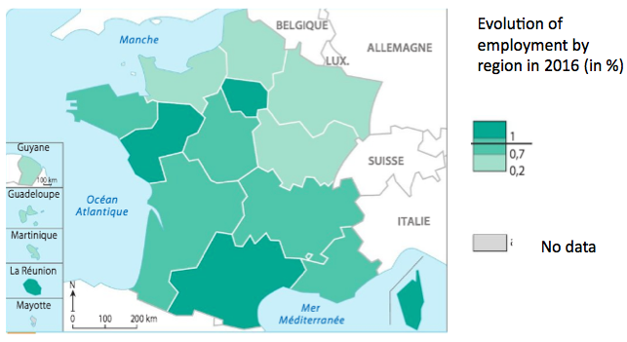

3. Define ‘tertiary sector’ and comment on its importance to the French economy.
4. Explain why SMEs and larger enterprises are both important to France.

5. What roles do State and EU level actors play helping French industry adapt to the challenges of globalization?

