Chapter 5: Urbanization and Coastal Productive Zones

1. What information is shown on the cartogram below? Are there any patterns discernible in terms of internet coverage? Can you account for any patters?
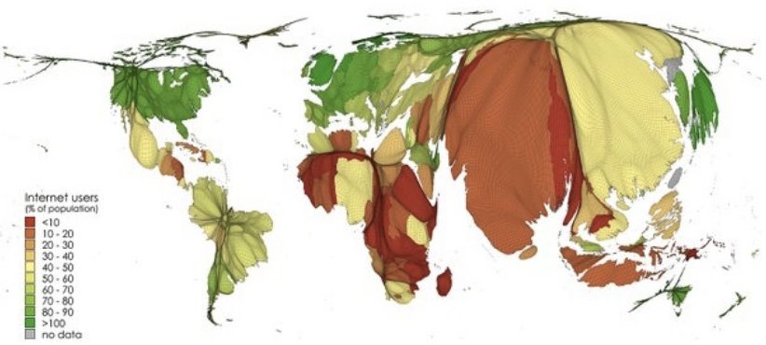

2. Briefly summarize the three types of flows.

3. What is ASEAN and how has Vietnam benefitted from globalisation?

4. What is shown in the photograph? Where was it taken? Explain what it represents?
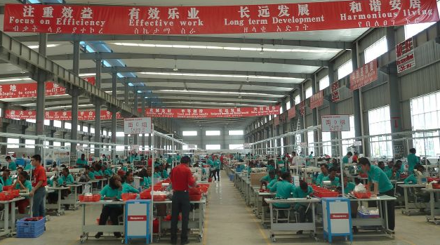
5. How does the NIDL differ from the old IDL?

6. In what way is the port of Rotterdam a multimodal hub?

7. What are clusters? What are the benefits of such spatial organisations?

