The UK joins the EEC: the 1970s

Document 1: BBC article from January 1st, 1973

The United Kingdom has become a fully-fledged (full / complete) member of the European Economic Community. Ireland and Denmark also joined Britain in becoming the newest members of the community, bringing the total number of member states to nine. At midnight last night a Union Jack flag was raised at the EEC's headquarters in Brussels to mark the occasion. Celebrations were held in the city and one of Britain's new European Commissioners, George Thomson, joined revelers (people celebrating) in a torch lit procession.

Prime Minister Edward Heath is optimistic that Britain's membership of the community will bring prosperity to the country. He said: "It is going to be a gradual development and obviously things are not going to happen overnight." But from the point of view of our everyday lives we will find there is a great cross-fertilization of knowledge and information, not only in business but in every other sphere. "And this will enable us to be more efficient and more competitive in gaining more markets not only in Europe but in the rest of the world."

More than 1,000 Britons will relocate to Brussels over the coming months to take up their places as civil servants of the community. Britain will be given four votes within the council, which proposes policies on issues ranging from the environment to public health.

Membership applications by the UK to join the EEC were refused in 1963 and 1967 because the French President of the time Charles de Gaulle doubted the UK's political will.
It is understood, however, his real fear was that English would suddenly become the common language of the community

http://news.bbc.co.uk/onthisday/hi/dates/stories/january/1/newsid_2459000/2459167.stm
Document 2: Information about the 1975 Referendum campaign result

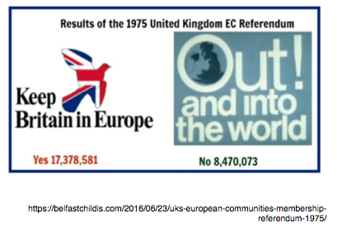
On June 5th 1975, the British people were asked to vote ‘Yes’ or ‘No’ in a referendum called by the country’s Labour government led by Harold Wilson, about Britain remaining in the EEC. 67.2% said yes.

Document Comprehension Exercises

Please answer on a separate piece of paper and write in complete sentences using the question to structure your responses. Do not forget to write a title, the date and put your name on the paper!

Document 1
1. What kind of document is this? When was it published?
2. Where are the EEC’s headquarters?
3. What happened at midnight and why were people celebrating?
4. Who was the British Prime Minister at this time?
5. Identify at least two ways in which the Prime Minister said that Britain would benefit from EEC membership.
6. Why did the UK have to wait until 1973 to join the EEC?

Document 2
7. What was held in 1975 and what was the outcome?

