The European Coal and Steel Community

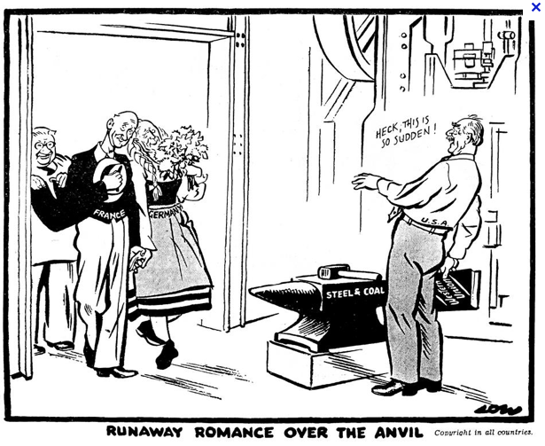

On 12 May 1950, referring to the Scottish tradition whereby couples go to blacksmiths’ forges in Gretna Green to exchange their wedding vows over the blacksmith’s anvil, the British cartoonist, David Low, illustrates the surprised reaction of Dean Acheson, US Secretary of State, following the Schuman Declaration of 9 May 1950.

Source: Daily Herald. 12.05.1950, No 10 663. London.

The Schuman Declaration

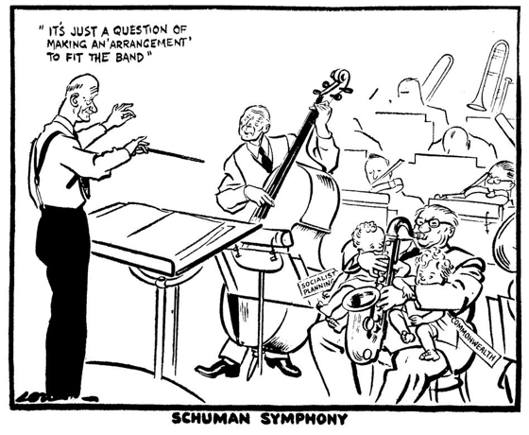

On 17 May 1950, cartoonist Low takes an ironic look at the difficult position of the United Kingdom with respect to the French plan to pool steel and coal production in Western Europe.

Source: Daily Herald. 17.05.1950. London.

