History Theme 1: Political Reform
The Suffragette Movement

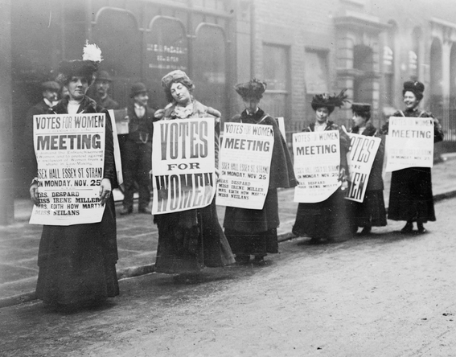

1. What do you think this photograph shows? (Guiding questions: Who are these women, what are they doing? What is written on their signs?)

2. What does the word suffragette mean?

3. Could women vote in Ancient Greece or the Roman Republic in Ancient times?

4. What happened when the franchise (ability to vote) was widened in the UK in 1832?
5. Which countries witnessed an intense struggle over women’s right to vote in the 19th century?

6. Identify where and when women first gained the right to vote in the late 19th and early 20th centuries.

7. What do you think this photo shows?

