Spain builds a colonial empire

Document 1: routes of the explorers
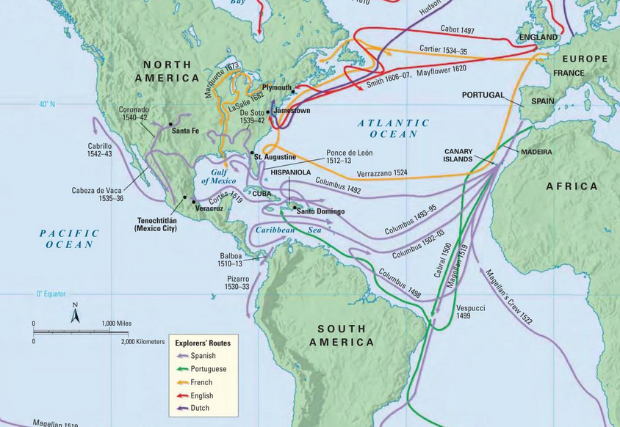

Document 2: Impact on the native population
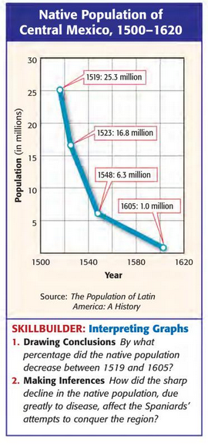
Document 3: Spanish conquests and Cortes

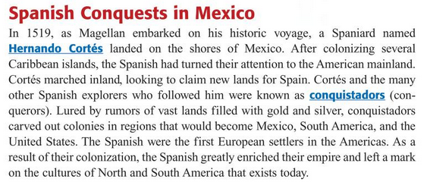

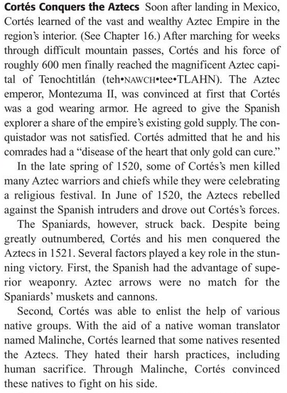

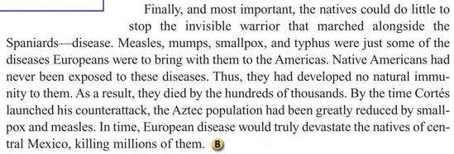

Document 4: The Encomienda System

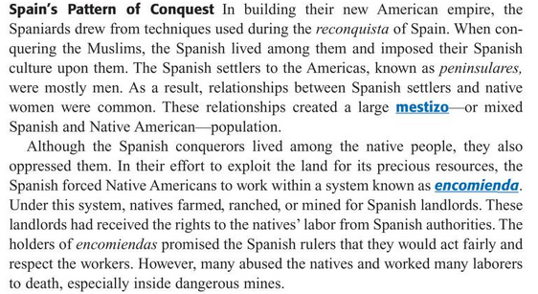

Exercises
(Use doc.1)
1. Cite three Spanish explorers who went to Central America.

(Use doc.2)
2. Describe, citing pertinent figures, what happened to the native population between 1519 and 1620.
3. How do you think this sharp drop would have affected Spaniards attempts to conquer and control the region?

(Use doc.3)
4. What drew the conquistadors to Central America?
5. Who was Cortés and how was he initially viewed by Montezuma?
6. Explain how Cortés, despite a considerable numerical disadvantage was able to conquer the Aztec Empire.

(Use doc. 4)
7. How did the encomienda system operate?
Bartolomé de Las Casas and the Valladolid Debate
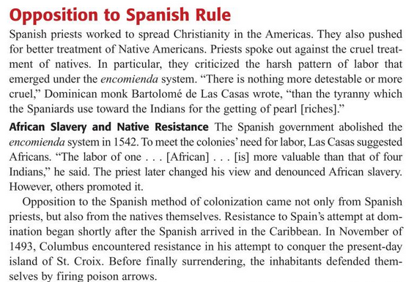

The Valladolid Debate

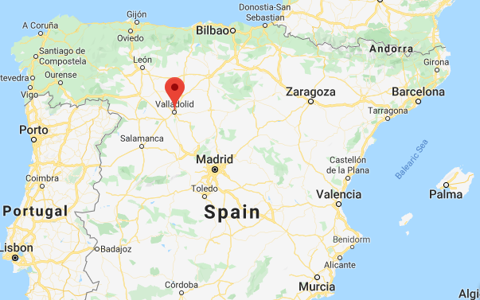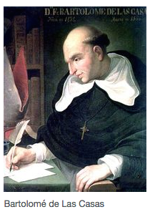
Location of the town of Valladolod

The Spanish discovery and subsequent conquest of the New World inspired a serious, if not heated, intellectual controversy regarding the rationality and Christianization of the Indians.

The debate reached its height in 1550, when the King of Spain, Charles V, ordered a junta, a group of jurists and theologians, to meet at Valladolid in order to hear the arguments in favour and against the use of force to incorporate the Indians into Spanish America. On the one side was one Juan Ginés de Sepülveda, a prominent humanist and Greek scholar who justified conquest and evangelization by war. His opponent, Bartolomé de Las Casas, in contrast, was a staunch advocate of peaceful and persuasive conversion. So it was that the most powerful man, Charles V, leader of the most powerful nation in the world, Spain, suspended all wars of conquest until a group of intellectuals grappled with the morality of Spain’s presence and enterprises in America.

Results of the debate

For example, Sepülveda’s arguments in favour of war as a means of pacification partly influenced the Council of the Indies in its policies of “war by fire and blood.” But the Las Casas’ movement against the advocates of conversion by force also found some backing both in New Spain and Peru. In northern New Spain, or the Chichimeca area, judge Alonso de Zorita and the Franciscan Jacinto de San Francisco adopted peaceful policies to pacify and convert the nomadic tribes. In the meantime, the debate led to a more serious study of Native American cultures. More and more missionaries, particularly Bemandino de Sahagün, came to learn Indian languages and culture, in the process documenting the natives’ rationality and overall way of life.

Factfile about Las Casas

Bartolome de Las Casas (1484 – 1566), was born in Seville, Spain. He was there when Christopher Columbus got to Seville in 1493 after Columbus' first trip to the Americas. His father, Pedro de las Casas, and his uncle went to the Americas in the second voyage of Columbus that left in November 1493. With his father, he went to the Caribbean island of Hispaniola in 1502 together with Nicolás de Ovando, the new governor of the island. In 1506 he went to Rome, Italy, where he became a Catholic priest.

He went back to Hispaniola in 1508 and moved to Concepción de la Vega, in the Cibao valley, and got an encomienda (land with the indigenous people living there). Then he went in 1513 to Cuba and the governor Diego Velázquez gave him an "encomienda". But soon Las Casas began to understand that the native people (Taínos in Cuba and Hispaniola) were treated as slaves in a very bad way, and he began to defend the native people. He later became the first Bishop of Chiapas, Mexico.

Exercises

1. What aspects of the encomiendia system did Spanish priests oppose?

2. What was a junta?

3. Who headed the two opposing sides at Valladolid debate? What were their main arguments or intellectual positions?

4. Describe two positive outcomes of this debate.

