Geography
Part One: Territorial Dynamics of Contemporary France
Chapter 3: Areas of Low Population Density and their Assets

Key ideas

The average population density in France is 118 inhabitants per km2 and this rises to 24 258 inhabitants per square kilometre in Paris. On the contrary, areas of low (or sparse) population density have an average of only 30 inhabitants in each square kilometre. Approximately 42 percent of the surface area of France has a low population density and this accounts for 4 million people or 6.5 percent of the country’s total population.

D.N.L. Vocabulary

Cattle (bétail): refers to cows and bullocks
Extensive cattle raising (l’élevage extensive): a method of raising cattle characterised by a low density of animals in each hectare
Enclave (enclavement): describes an isolated territory which is difficult to access and poorly connected to the exterior
Heritage (patrimoine): term used to describe all the historical sites of interest and monuments in a region
Population density: the average number of inhabitants in an area of one square kilometre

Population Densities across the Country

Translations

1. Sparsely populated spaces
Areas of low population density (less than 50 inhabitants per square kilometre)
Areas of average population density (more than 50 inhabitants per square kilometre)

2. Densely populated spaces
Yellow = Urban areas
Orange = Major built up areas

What are the assets of areas of low population density?

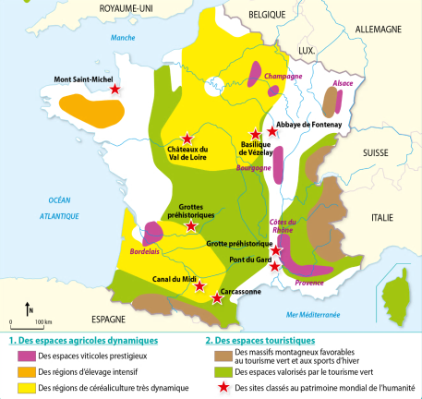

Translations
1. Dynamic Agricultural Spaces 2. Touristic Spaces
- Prestigious wine production - Mountainous areas for ecological tourism
- Intensive animal breeding and winter sports
- Dynamic arable agriculture - Ecological tourism
- Global heritage sites

What are the dynamics of Sparsely populated areas?

The average population density in France is 118 inhabitants per square km. Spaces which are considered to be sparsely populated have a density of less then 30 people per square kilometre.

The least populated parts of France are the mountainous regions such as the Alps, Pyrenees,
Massif Central, Vosges and the Jura. The angles of their slopes, altitude and amount of winter snowfall are all obstacles to higher population densities.

Areas that are far from the coasts or borders with other countries are also less densely populated. Transport axis are less numerous in these regions and population ageing is notable.

However, sparsely populated areas are currently experiencing an influx of newcomers. These are people who wish to move away from built-up urban areas in order to live in a calmer environment, closer to nature. These spaces often have very dynamic agricultural sectors in terms of intensive cattle raising and intensive arable farming. These rural areas also take advantage of their potential for tourism, with winter sports in the mountainous areas and walking and all terrain cycling holidays in other areas.

Case Study: Why is Morvan losing inhabitants?

Morvan is rural space situated in Bourgogne. It is a fragile agricultural territory which is losing inhabitants and has an ageing population.

1. An example of Extensive pastoral agriculture

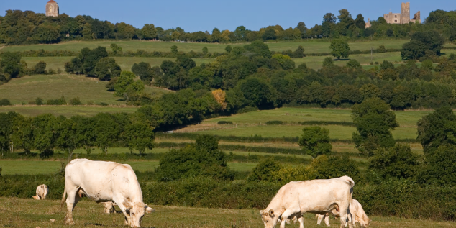
The raising of cattle in this area takes place on small farms and the cattle spend most of the year in the fields.
2. A Falling and Ageing population

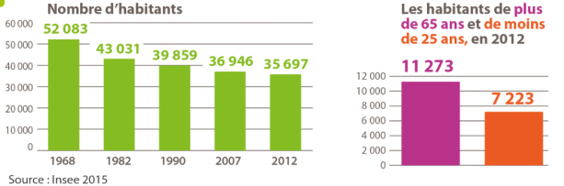

Translations
Number of inhabitants
Inhabitants over 65 years old and less than 25 years old in 2012

3. Vézelay, a commune of Morvan

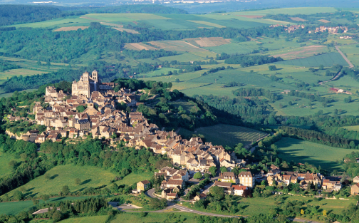

Vézelay is village of 483 inhabitants (2013) situated at 277 metres of altitude. The population density of the commune is 20 people per square kilometre. The biggest village in the area, Châtel-Censoir (647 inhabitants) is 11km away.

Case Study: What are the advantages of Sarlat?

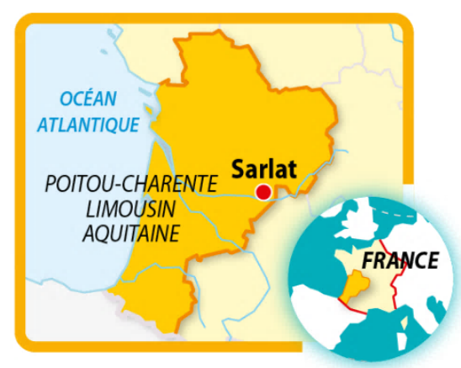
Sarlat is small town of around 10 000 people situated in a sparsely populated region. It is encircled by some of the most beautiful villages in France and has a rich historical heritage which is attractive to tourists.

The market

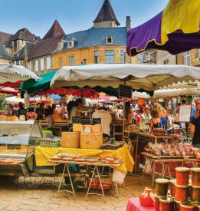

Twice a week, the market at Sarlat attracts local inhabitants and tourists who come to buy local products that are reputed throughout the region (e.g. foie gras, truffles, nuts etc).

Dordogneshire

During the early 2000s, significant numbers of people from England bought property in Dordogne for their retirements. They renovated old houses back to their former glory and this caused a sharp rise in prices as demand for homes in the area increased. However, over the four year period from 2008-2009 onwards, many of the English inhabitants saw the value of their pensions fall due to the near parity between the pound and the euro and this has led to a reduction in the number of English buyers in the region.

An exceptional heritage

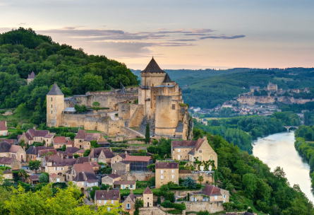

The chateaux of Castelnaud and Beynac (in the background)

The Tourism Sector

Owing to its rich historical heritage, tourism plays an important role in the department of Dordogne. Tourism accounts for 5% of all salaried employment and around half of the jobs linked to tourism are in hotels and restaurants. Sarlat is one of the most visited touristic sites in the department.

During the 2011 summer season, 3.6 million nights were recorded by tourists staying in hotels and on camping sites in Dordogne. Over 40% of these tourists came from overseas, principally from the Netherlands and the UK.

