Early Villages: Example of Çatalhöyük
https://www.khanacademy.org/humanities/prehistoric-art/neolithic-art/a/atalhyk

Objective: to make structured notes about an early village settlement in Turkey

1) What is Catalhoyuk and in which modern day country is it located?

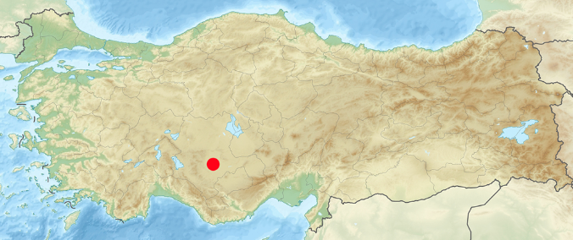

2) When was it inhabited and how many peopled lived there?

3) How were the houses built and how did people enter them?

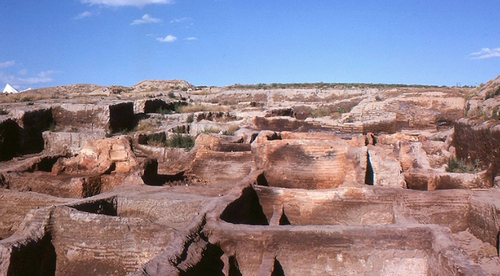

4) Where did people bury their dead?

5) What has been found in nearly every excavated house?

