What is the extent of French Maritime Power?

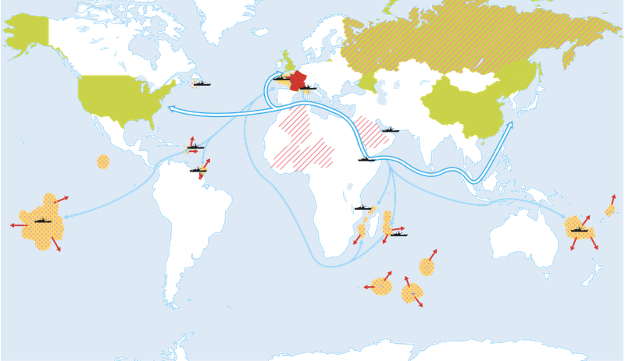

Legend
Control of maritime space across the world

Securing maritime space across the world

Appropriation of seas and oceans

