Extract from the Forward to The Ocean Economy in 2030 by OECD (2016)
Source: https://geoblueplanet.org/wp-content/uploads/2016/05/OECD-ocean-economy.pdf

The ocean economy is essential to the future welfare and prosperity of humankind. It is a key source of food, energy, minerals, health, leisure and transport upon which hundreds of millions of people depend. However, the maritime industry landscape is poised to undergo a profound transition. Long considered the traditional domain of shipping, fishing and – since the 1960s – offshore oil and gas, new activities are emerging that are reshaping and diversifying maritime industries.

The new “ocean economy” is driven by a combination of population growth, rising incomes, dwindling natural resources, responses to climate change and pioneering technologies. While traditional maritime industries continue to innovate at a brisk rate, it is the emerging ocean industries that are attracting most of the attention. These industries include offshore wind, tidal and wave energy; oil and gas exploration and production in ultra-deep water and exceptionally harsh environments; offshore aquaculture; seabed mining; cruise tourism; maritime surveillance and marine biotechnology.

The long-term potential for innovation, employment creation and economic growth offered by these sectors is impressive. But economic activity in the ocean is also characterised by a complex variety of risks that need to be addressed. Foremost among them are those related to ocean health from over-exploitation of marine resources, pollution, rising sea temperatures and levels, ocean acidification and loss of biodiversity. Unsustainable use of the ocean and its resources threatens the very basis on which much of the world’s welfare and prosperity depend. Realising the full potential of the ocean economy, therefore, will demand responsible, sustainable approaches to its economic development.

What makes the ocean economy different from a land-based economy?

Difference #1: The sea is much larger than land. Implication: Natural marine processes, ecosystems and species are not confined to maritime legal boundaries. Different legal regimes apply to a single activity depending on where it takes place, even within the jurisdiction of a single coastal country (territorial waters, contiguous zone, economic exclusion zone), and is further compounded by the interests of other countries in areas beyond national jurisdiction (international waters).

Difference #2: Water is less transparent than air. Implication: Remote sensing technology is not able to penetrate deep below the sea’s surface. This makes it much harder and much more expensive to know what’s going on in the water column and the seabed. Marine research and monitoring costs are extremely high, which helps explain why we know much less about what goes on in the ocean than about what happens on land.

Difference #3: The sea is more three-dimensional than land. Implication: Marine life occurs from the sea surface down to the deepest ocean trench, while on land only comparatively few species (i.e. those with the ability to fly) can sustain themselves above the land surface. The same also applies, to a certain extent, to human activities. This renders two-dimensional maps less useful, and increases the complexity of marine spatial planning and management. It also makes it more difficult to study the marine environment, how it works, how it is affected by human activities (see difference #2), and how the ocean benefits the economy and human well-being.

Difference #4: The sea is fluid and interconnected. Implication: What happens in one place may affect what happens elsewhere, as pollutants and alien species are carried by ocean currents and/or vessels to much greater distances than on land.

Difference #5: Marine species can potentially travel much longer distances than terrestrial ones. Implication: This makes the management of human activities that use marine resources particularly difficult, as they are accessible to almost anyone.

Difference #6: Aggregations or clusters of animals in the water column can shift rapidly from one location to another. Implication: The mapping of these species and their movements is more difficult, and measures to protect or manage them need also to shift in time and space accordingly.

Difference #7: Nutrients and pollutants can be retained for several decades until they are returned by ocean circulation. Implication: There can be significant time lags between the periods when certain human activities take place and the time when their impacts occur, potentially placing significant burdens on future generations.

Difference #8: Lack of ownership and responsibility in the ocean are even less favourable to sustainable development than on land. Implication: Private utilisation of the ocean and its resources is usually dependent on licenses or concessions from public authorities. National authorities have the power to allow private activities in areas under the jurisdiction of the coastal state; the International Seabed Authority can license activities in the area, but in international waters, private activities have much fewer controls. Common property regimes are even scarcer than on land given the mobile nature of many marine resources, which makes the exclusion of non-authorised users extremely difficult.

Difference #9: Humans do not live in the ocean. Because the sea is not our natural environment, our presence is dependent on the use and development of technology. Our sparse presence in the sea also makes it much more difficult, and costly, to exercise adequate law enforcement.

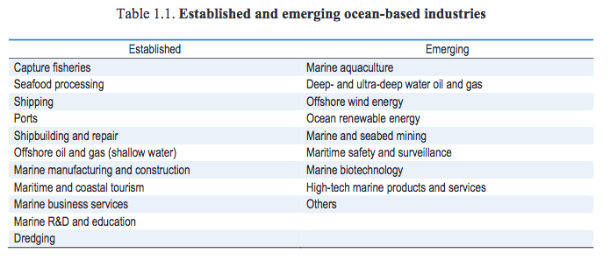
The objective of these exercises is to make you critically reflect on what is discussed in the document and think more deeply about this issues of maritime resource use and conflicts.

1) Explain the meaning of each of the terms in bold, within the context of how they are used in this text.

2) Identify the factors provoking the creation of the new ocean economy and cite examples of some of the activities involved.

3) ‘Unsustainable use of the ocean and its resources threatens the very basis on which much of the world’s welfare and prosperity depend.’ Justify this assertion, citing evidence from the text.

4) Why and how does the fact that maritime resources are not confined to maritime legal boundaries complicate maritime activities?

5) Thinking about differences 4, 5 and 6: explain how the interconnectedness of the oceans poses challenges in how martin environments are managed.

6) Reflecting upon differences 8 and 9: what challenges are posed by the sparse human presence in international waters and the lack of control over private potentially polluting, activities?

Grade descriptors
0-8 pts: simplistic, copied responses that suggest the student has not engaged with the concepts raised in the document.

9-12pts: more developed responses given though explanations are not sufficiently developed.

13-16pts: responses demonstrate understanding of the issues and provide a degree of insight

17pts+: excellent, critical analytical responses which demonstrate clear insight on the part of the student.

