T°OIB Geography
Theme 1: Seas, Oceans: at the heart of Globalization
AMQ Exercise

Reminder about Methodology

AMQs (Annotated Map Questions) require you to draw an annotated map (croquis) and create an organized key or legend, and then using your map, a document and your knowledge to write a 2 page response (short – essay) to a prompt.

You must produce a neat and easy to read annotated map (use coloured pencils and a few felt-tip pens - avoid ballpoint pens and markers and never use highlighters).

Between 10-15 symbols should be used in the legend (ideally 12).

The Information in the legend must be hierarchically categorized (through use of colour and size of symbols) using all four types of representation (areas, lines, arrows, points). Places and names must also be correctly labelled on the map.

Finally, you will need to use your map, together with your knowledge from lessons and a document to write a 2 page response to a prompt.

Guidance for how to construct an Annotated Map
An annotated map ALWAYS includes: | Methods | Principles
A title | Clear and underlined | In History, it has to contain a date  In HG, it has to indicate the space concerned
A scale | Written on the blank map
An orientation | An arrow indicating the direction of the North | On an angle of the map
A legend / key | Organized into several parts | NEVER write the legend on the back of your paper, NEVER above your map  The legend is always written on the right of the symbol, or on a side page
Symbols | Several categories of symbols:  areas, lines, arrows, points | Use a ruler for shapes and lines
An annotated map must to be NEAT, and use regular drawing tools (NO highlighter, NO glitter)

Guidance for creating an Annotated Map Key or Legend
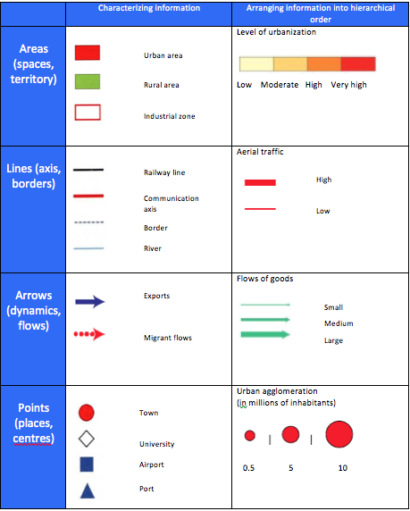
There are 4 basic types of symbols to include on your map in order to represent information:

Areas (e.g. state at the heart of globalization)

Lines (e.g. a communication route)

Arrows (e.g. merchandise flows)

Points (e.g. the location of a city)

The following pages show two examples of annotated maps with keys (legends) about Geography Theme 1. Use them to as a source of information and reference to help you construct your own annotated map and key (legend) in response to the exercise on page 8 of this booklet.
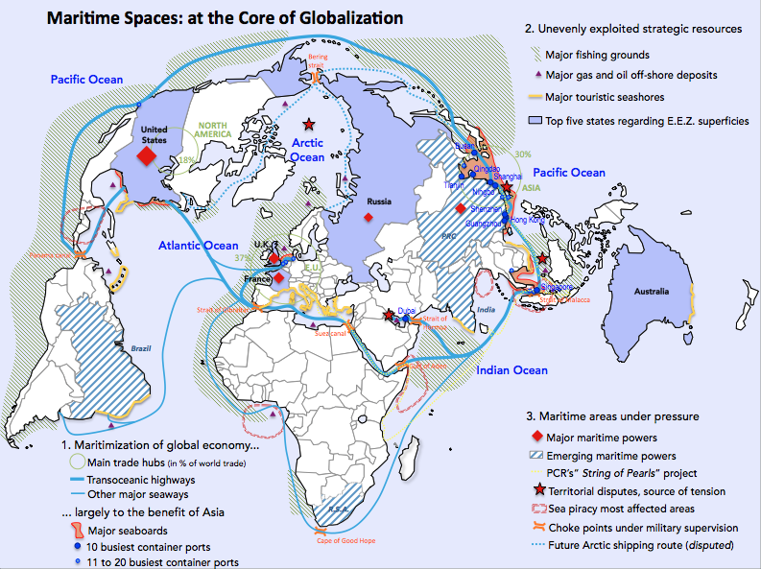
Maritime Spaces at the heart of globalization
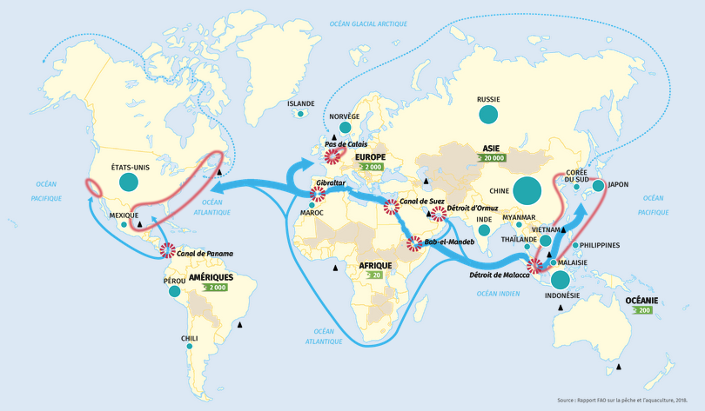

Key (legend)

1. Maritime resources at the heart of globalization
Fishing yields at sea (in millions of tonnes)
1-2 2-4 4-6.5 Over 15

Aquaculture production (in millions of tonnes)
over 20 over 200 over 2 000 over 20 000
Land locked state

Principal off-shore deposits of oil and gas

2. Spaces traversed by global flows
Principal maritime route

Other important routes

Developing maritime routes

Choke points

Major ports

Geography Annotated Map Question

Part A

Draw an annotated map, including the legend (map), on the topic: Seas and Oceans at the core of globalization.

(Instructions: Use the base map you have been given, remember to give your map a suitable title and use the four types of symbols on your map as appropriate. Do not forget to included 12-15 symbols maximum on the legend and remember to organize the legend into two or three categories).

Part B

Using the annotated map, the document and your own knowledge, write a short essay (should include a thesis, body, brief conclusion; roughly two sides) to answer the following question: Explain why maritime spaces are vital to globalization and yet also areas of tension.

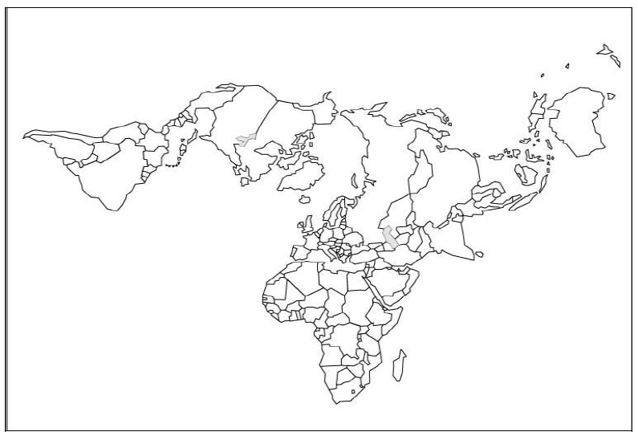
Key (legend)

Document for AMQ Exercise

China and India fight for the gates of the Strait of Malacca
19/01/18

The Strait of Malacca, which connects the South China Sea with the Burma Sea on its way to the Bay of Bengal, is the busiest commercial crossing in the world and, therefore, is a strategic place. Through this corridor that surrounds the western coast of the Malay peninsula and the Indonesian island of Sumatra, approximately 60% of the world's maritime trade transits, exceeding one hundred and fifty ships per day and is the main source of oil supply for two of the main Asian consumers; the People's Republic of China and Japan. This geographical point is key for the entire Indo Pacific region, thus ensuring the free movement of ships becomes strategic. That is why many States in the region, including China and the United States, see the need for protection of this passage in order to be able to supply themselves, export their merchandise and not be blocked by the control of a third country over this area.

In relation to China it is not easy to think that a blockade of its supply due to problems in the Strait of Malacca will happen. In order for this to happen, an armed conflict of great dimensions would have to be generated, propitiating this blockade by a subject that could control - and potentially interrupt - the passage towards the other countries of the region. This potential risk, which today can only be generated by the United States Navy, forces China to be alert and have to develop sufficient military capabilities to protect what it considers its territories in the South China Sea and, by extension, the supply of vital resources that must necessarily cross the Strait of Malacca.

The positions and presence of the Asian giant in the South China Sea and in the areas adjacent to the Strait of Malacca have increased over the last years, in order to increase its influence on the States of the region. Moreover, to defend its oil and natural gas supplies (from the Persian Gulf), China has extended its presence to the Indian Ocean, although this is not enough. The reality is that in this area there is a great competition between two of the Asian powers with more influence in the region: China and India. Due to the increasing presence and influence of the People's Republic in the Indian Ocean, India has been forced to take proactive measures to improve peace and stability in the region, mobilizing and expanding its presence from its east coast towards the Strait, in order to rebalance the regional power. With this, India can dominate the western access to the Strait and, therefore, have a longer reaction time to maneuver in the Indian Ocean as in the Strait itself and, even, access to the waters of the South China Sea more agilely.

At the same time, this growing approximation of India to the South China Sea, is observed with concern in Beijing, and even, some analysts see India as a threat if an hypothetical case of a war between the two regional powers could occur and India were to block the Strait and, therefore, China's access to certain raw materials and other resources. For this reason, China has carried out various military maneuvers in the past three years together with third States in the Strait of Malacca, especially with Malaysia.

