Mumbai Case Study of a LEDC Megalopolis

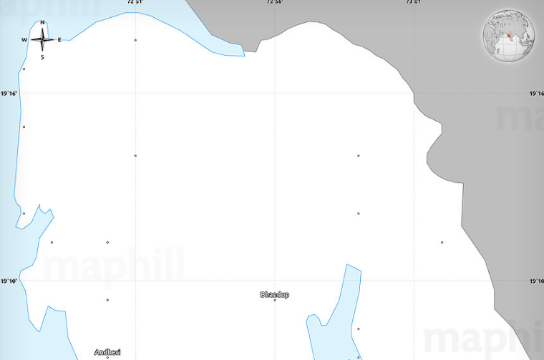
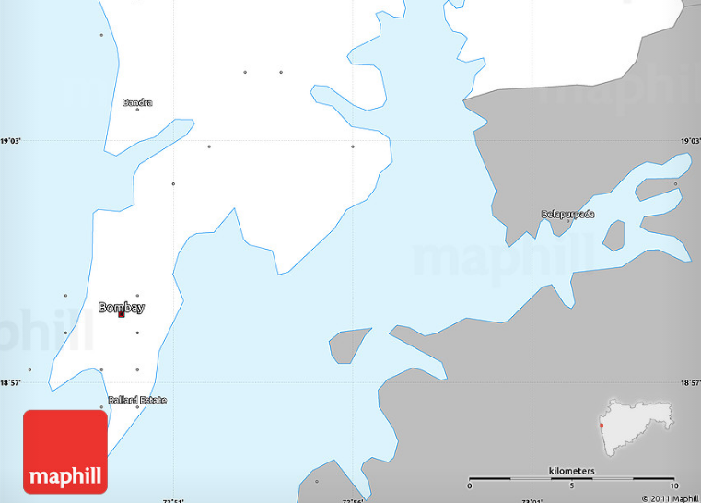

Map key (Legend)

Written exercise

Using your map and the documents you have been given about Mumbai, write a short essay (1.5 – 2 pages) to describe how and why Mumbai has expanded:

- describe the site and situation of Mumbai
- describe and explain how it has developed (mention railways lines, industry, suburbs etc)
- explain why it is growing
- identify the challenges facing the city and solutions (you should also comment on the difference and appropriateness of top down vs bottom down development)

