Geography Theme 2: Chapter 2
France and the USA: a comparison of maritime powers

For both the US and France, seas and oceans have economic, environmental and geostrategic importance. France and the United States control the two largest exclusive economic zones (EEZs), (even though the US has not ratified the UNCLOS), and they assert their respective maritime power despite the loss of competitiveness of their ports. On the one hand, this topic focuses on the economic role of maritime spaces, especially with regard to resources, the flows of goods and information. On the other hand, it is important to examine the military and diplomatic aspects of maritime power exercised by France and the United States.

November Major Essay Assignment

Using the documents and your own knowledge, evaluate the economic, diplomatic and military importance of maritime spaces for France and the United States respectively.
France and the USA: a comparison of maritime powers
PART ONE: FRANCE
Diverse maritime spaces
France has territorial sovereignty over an extensive maritime space. The principal actors within this space are concentrated in the 66 French ports located in French territory all over the world. Certain ports specialize in the handling, distribution, stocking and transformation of merchandise such as petroleum processing at Le Havre and the processing of fish at Boulogne-sur Mer. The French coastline has also been reconfigured to support the exploitation of maritime resources and local economies: salt, shellfish farming (conchyliculture), mussel farming (mytiliculture), oyster culture (ostréiculture) have become world-renowned French maritime products for example.

Largest EZZ in the world
Due to its overseas territories France possesses the largest EZZ in the world which now covers, since being extended by official decree in September 2015 around the islands of Martinique and Guadeloupe, plus Guyane and Kerguelan (Indian Ocean) and New Caledonia (South Pacific), 570 000 km2. However, the EEZ can provoke conflicts with neighbouring states and the extension to the EEZ around Saint-Pierre-et-Miquelon in the North Atlantic has not been officially enacted due to diplomatic opposition from Canada because of potential hydrocarbon reserves in this area.

Maritime space of Saint-Pierre-et-Miquelon: a space under multiple tensions
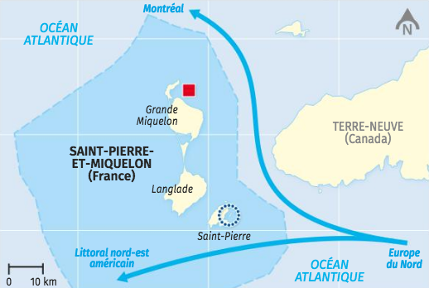

A French territory and fishing zone enclave within Canadian territorial waters
Canadian EEZ

French EEZ in which Canadian quotas for the fishing of cod (morue) are in vigour
Development perspectives in a zone under pressure
Aquaculture (scallops, cod and mussels)

Container port project

Major maritime routes
A military presence in all oceans

Naval vessels, both ships and submarines contribute to France’s military power and form a considerable dissuasion force. Along with the USA, France has also invested in a nuclear powered aircraft carrier, the Charles de Gaulle. However, it is principally through the existence of four nuclear propelled submarines that France maintains a permanent seaborne nuclear deterrent force since at least one of these vessels is always at sea. This is backed up by naval base infrastructure throughout the world. French forces also conducted boat patrols across the globe notably in the fight against drug trafficking and piracy. However, following the end of the Cold War and expenditure cuts there has been a 20% reduction in the number of boats in the French fleet.

Challenges of international rivalry

French ports have struggled to remain competitive in the face of world and European competition. The ports of Marseille and Le Havre occupy 53rd and 68th place respectively in world rankings whilst the port of Rotterdam is at 9th place. To address this challenge large state sponsored modernization projects have been implemented to reinforce the competitiveness of French ports (e.g. Project Neptune at Dunkerque and Port 2000 at Le Havre) and diversify their activities through the development of tourism (e.g. via aquariums, museums etc). The State has also continued to play a military role through financing the military-industrial complex in Brest, Cherbourg and Toulon. It has also encouraged the development of technological poles in the marine engineering and telecommunications domains such as those at Brest-Iroise and Lorient Technopôle.

An under-exploited domain

France enjoys clear advantages in the maritime domain as evidenced from the construction of ships at Saint-Nazaire and La Ciotat which benefit from the strong demanding of the ocean liner cruise industry. However, certain coastal industries are in decline and generate wastelands which are expensive to clean up and put to different uses. Renovation projects, such as those at Marseille enable declining port cities to be revitalized.

Whilst activities such as fishing remain important around France and the French Southern and Arctic Zones (TAFF: Terres australes et antarctiques françaises) in addition to Saint-Pierre-et-Michelon, raw materials such as hydrocarbons and polymetallic nodules, frequently present in the overseas territories, are not yet exploited.
Importance of the TAAF in terms of France’s EEZ

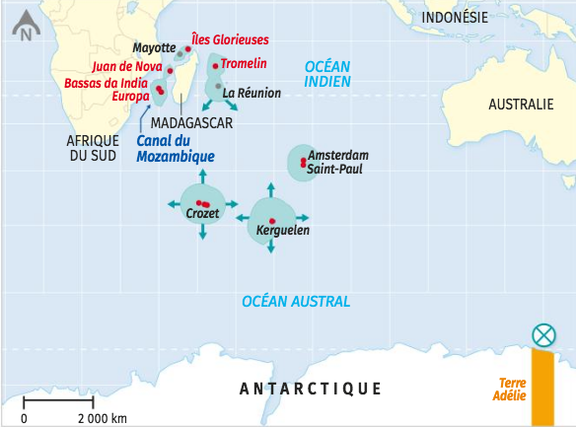

Peripheral islands without permanent populations

French Southern and Arctic Zone (TAFF)

Adélie Land: Antarctic territory administrated by France under the Antarctic Treaty System (ATS) which entered into force in 1961

Les Iles Éparses : a scattered group of small islands

Vast EEZs associated with the TAFF
EEZ

The Adélie Sea: under the ATS this is not considered as an EEZ

Extraplac programme – a proposition to extend the EEZ beyond 200 nautical miles

The Tromelin isle is a good example of the advantages the EEZ offers to France. Situated within the vicinity of Madagscar it’s surface area is no more than 1 km squared yet it possesses a ZEE that extends over 280 000 km squared. UNCLOS allows the free circulation of vessels within this area but the use of its resources is exclusively for France.

How does the port of Marseille-Fos maintain its attractiveness?

Marseille-Fos is the first French port in terms of merchandise and cruise traffic but has been overtaken by other ports for passenger traffic (Dunkirk and Calais) or containers (Le Havre) and has suffered from major competition at a European level. The major actors of this port are seeking to change the port’s image in order to attract new activities and re-launch the maritime economy.

Marseille-Fos: a major French port but of secondary importance at a European and World scale.

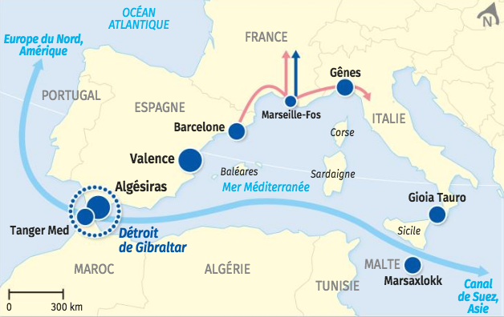

Container traffic captured by ports closest to major maritime routes (in millions of TEU – Twenty foot Equivalent Unit which refers to the volume of a single container)
4.3 to 4.8
2.4 to 3.3
1.4 (in millions of TEU – Twenty foot Equivalent Unit which refers to the volume of a single container)

Principal maritime routes

Strategic choke points

Marseille-Fos: a relatively limited hinterland
Land routes (motorways and high speed railways)

River route in development

The port of Marseille faced with its competitors
Port traffic (in millions of TEU)

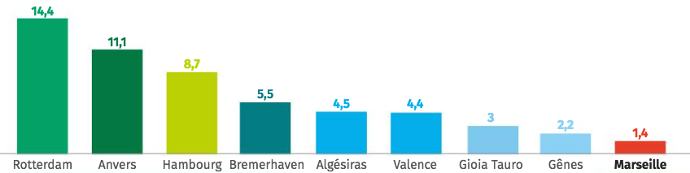
The ports of Rotterdam, Antwerp, Hamburg and Bremerhaven account for 89% of European maritime traffic
Marseille handles 10 times less than Rotterdam

Features of Marseille: CMA CGM and Corsica Linea
The CMA CGM tower, France’s biggest maritime transport company and headquarters is located at Marseille, along with the boat of Corsica Linea which assure the link between ports in Corsica, Algeria and Tunisia.

CMA CGM is the third largest maritime transport carrier in the world, carrying each year, peaking in summer, 12 billion bananas, 900 million pineapples and 2.5 billion kiwis, principally from New Zealand to Europe and the rest of the world. CMA CGM has invested in the development of specially built containers which control the flow of oxygen to put fruits into a ‘state of sleep’ during their long journeys. This innovation has allowed certain clients to transport new products such as avocados from South America to Asia, a development which was impossible even a few years ago according to Éric Legros, director of special products and high value added services at the group CMA CGM.

Adapted from: Julien Pompey, ‘Marseille: dans les coulisses du transport des produits phares de l’été’, La Provence, 21st August 2019.

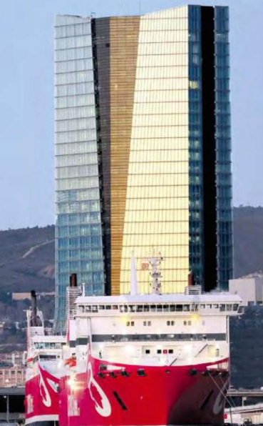

The port in figures
1st port in France
2nd biggest (in terms of tonnage) in the Mediterranean
1st port for cruises in France, in the top 5 of ports in the Mediterranean
400 hectare port facility in the city of Marseille
1 industrial-port zone at Fos extending over 10 000 hectares (size of the surface of the city of Paris)
41 500 employees (direct and indirect)
400 ports serviced worldwide
22 stopovers by container vessels each day
81 million tonnes of merchandise treated in 2017
10% increase in the amount of containers handled between 2016 and 2017
2.7 million passengers in 2017

Marseille Port Map

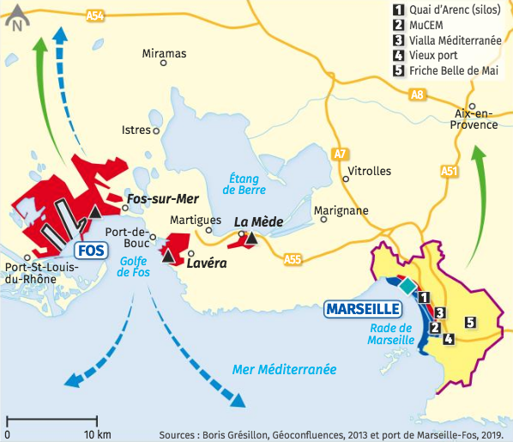

1.Renovation of old port to diversity its activities
Euromediterranean, the biggest urban renewal site in Europe

Renovated waterfront

New cultural projects

New terminal for cruisers

2. Modernisation of the port of Fos
Industrial Port Zone

Fos 2, 3 and 4XL: new container port terminals

Commercial flows beyond the hinterland with travel times exceeding those of North
European ports

Competition from other European ports

Diversification of port activities

Marseille will host the 2024 Young Olympics. As part of the diversification of the port, the MuCEM (Museum of Civilizations of Europe and the Mediterranean) was opened in 2013 when the city obtained the status of European capital of culture. The museum figures amongst the ten most important in France with frequentation gently increasing in 2018 with 1.5 million visitors. These economic diversification activities have been carried out by local actors, notably the municipality of Marseille and the Aix-Marseille-Provence metropole with the encouragement of the State.

Fos 2XL: a terminal to address European competition

Since 2011 with the coming on stream of the Fos 2XL terminal in the Darse 2 port (built in 1967-68), the amount of merchandise handled by the port has risen by 49% with more than 12 million tonnes processed in 2016 which equates to an additional 1 million containers. A further recent trend is the increase in the average size of container ships. Five years ago such vessels could carry between 8 000 and 10 000 containers, today it is rare to see vessels carrying less than 16 000 containers and measuring up to 400 metres in length. Loading and unloading such ships requires considerable technological infrastructure. This project has been managed by GPMM (Grand Port Maritime de Marseille) and two of the terminal operators. It is an important project since it enables Marseille to reach a level of operations which will place it among the biggest ports of Europe.

‘Grand Port de Marseille’: Fos 2 veur passer à la taille extralarge’, La Marseillaise, 18 Mars 2017.
Fos 2XL: a terminal to address European competition

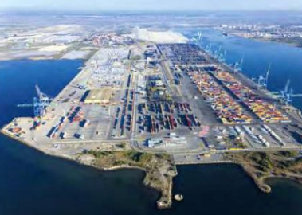

France and the USA: a comparison of maritime powers
PART TWO: USA

The Distinction between the coastal economy and the ocean economy

The NOEP (National Ocean Economics Program) distinguishes between the ocean economy and the coastal economy in the US. The coastal economy consists of all economic activities in the coastal region from barbet shops to surf shops and measures this in terms of the following sectors:

- Natural resources
- Construction
- Manufacturing
- Transport/Utilities
- Wholesale
- Retail
- Finance, Insurance, Real Estate
- Services
- Public Administration

However the ocean economy represents a range of goods produced and services performed all over the USA and includes 21 industries in six sectors.
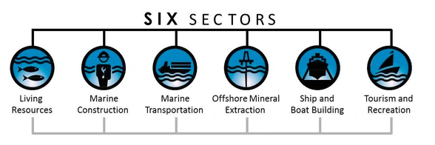

Certain industries, like commercial fishing, obviously depend on the sea and are wholly included. But only portions of other industries qualify; the tourism & recreation sector, especially, is full of these cases: There are many luxury hotels in America, for example, but only the ones in shore-adjacent zip codes can be said to depend on the sea.

The two pillars are the mineral extraction and tourism & recreation sectors. The minerals sector includes offshore drilling and exploration of oil and natural gas—a business that is booming. And there remains a solid American tradition of flocking to the seashore for vacations. But these two sectors dominate the ocean economy in different ways. Nearly three out of every four ocean economy jobs are in tourism & recreation, but 65 percent of the ocean economy's GDP comes from other sectors. The workers in the minerals sector, who account for only 5 percent of ocean-related employment, contribute over six times that to the total ocean-related GDP.

In 2011, the minerals sector surpassed tourism & recreation on the GDP measure—accounting for 37 percent of the ocean economy's productivity.

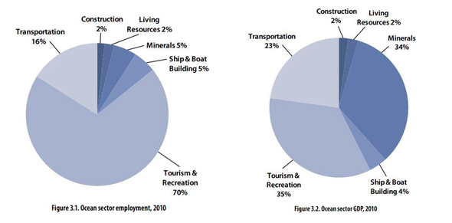

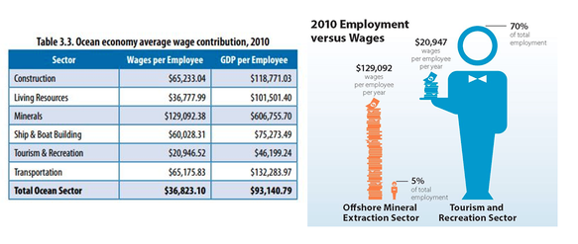

Tourism & recreation is a service-oriented sector; the minerals sector is about producing high-value goods. The workers' wages reflect this.

Adapted from: SVATI KIRSTEN NARULA, writing in The Atlantic, MARCH 21, 2014

How important is the ocean to our economy?

The ocean is the trading route for the planet.

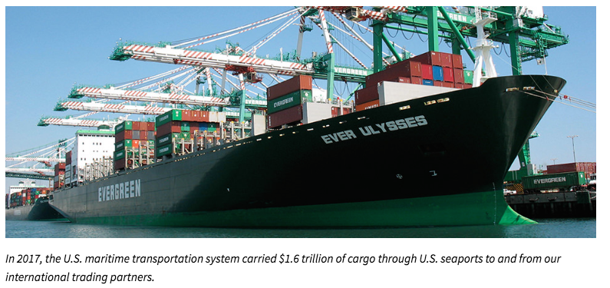

The U.S. economy is very dependent on healthy coastal and ocean resources. Consider the following facts:

- Fourteen percent of U.S. counties that are adjacent to the coast produce 45 percent of the nation's gross domestic product (GDP), with over three million jobs (one in 45) directly dependent on the resources of the oceans and Great Lakes.

- In 2017, the ocean economy, which includes six economic sectors that depend on the ocean and Great Lakes, contributed $307 billion to the U.S. GDP and supported 3.3 million jobs
- Tourism and recreation account for 73 percent of the ocean economy's total employment and 42 percent of its GDP. Offshore mineral extraction accounts for another 25 percent of the ocean economy's GDP.

https://oceanservice.noaa.gov/facts/oceaneconomy.html

2018 National Economic Impacts of the U.S. Deepwater Port System- Summary of Results

Direct jobs are those jobs with local firms providing support services to the seaport. Seaport direct jobs include jobs with railroads and trucking companies moving cargo to and from the marine terminals and private terminals. Induced jobs are jobs created locally and throughout the national economy due to purchases of goods and services by those directly employed. These jobs are with grocery stores, the local construction industry, retail stores, health care providers, local transportation and éducation service etc. Indirect jobs are those jobs generated in the national economy as the result of local purchases by the firms directly dependent upon seaport activity. These jobs include jobs in local office supply firms, equipment and parts suppliers, maintenance and repair services etc.

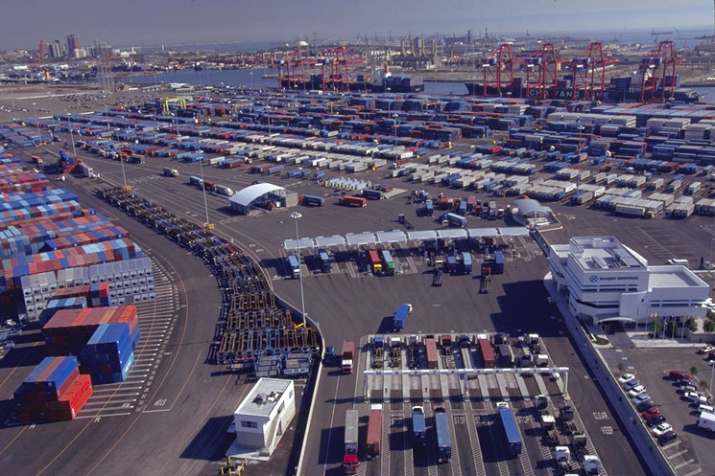

The average annual income of $62,800, compares to an average overall U.S. mean salary of $50,620 in 2017.
2014 vs. 2018 National Economic Impact of U.S. Deepwater Port System Comparisons

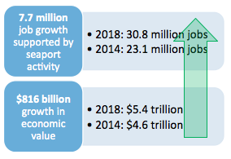

Adapted from: 2018 National Economic Impact of the U.S. Coastal Port System: Executive Summary, March 2019

US Ports

Receiving ever larger ocean vessels and delivering into dynamic logistics supply chains, the top U.S. ports have had to adapt to stay competitive and meet increasing volume demands year over year. The Panama Canal expansion (2016) continues to be a prime driver of infrastructure investment across the U.S. To prepare for the larger “post-Panamax” vessels calling on their docks, ports across the country have launched billions of dollars’ worth of development projects.

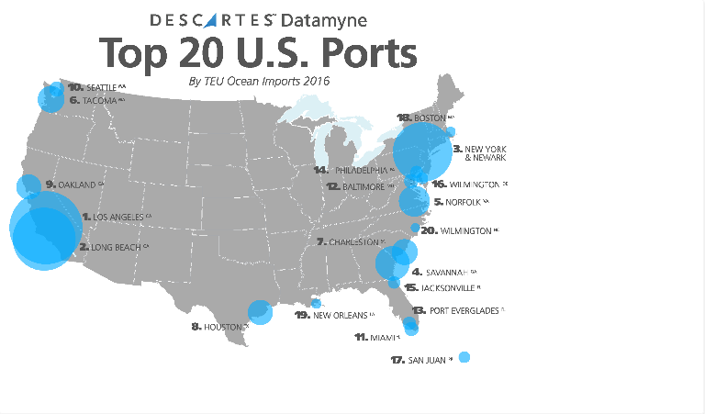

1. Port of Los Angeles
The Port of Los Angeles is located in the San Pedro Bay of the western US state of California. Given it’s strategic location, it’s no wonder that it’s responsible for the majority of the Transpacific trade. Also nicknamed America’s Port, it occupying 7,500 acres of land and with a 43-mile long waterfront, it handled nearly 4.4 million TEUs in 2015. This accounts for 13.5% of the North American market share. Since 2000, it’s held the post as the top port in the US. It currently ranks as the 19th busiest port in the world in terms of container volume. It’s estimated that around $1.2 billion worth of cargo is shipped to/from the Los Angeles port every day.

2. Port of Long Beach
Right next to the Los Angeles Port sits its sister port – the Port of Long Beach. It handled over 4.9 million TEUs in 2015, representing 12.1% of the North American market share. Together with the Port of Los Angeles, they’re responsible for over one quarter of the total container trade in North America. Annual trade movement at the Long Beach Port is valued at $180 billion annually. Shipping containers to/from Long Beach is extremely popular as it is considered as one of the major gateways for trade with Asia.

https://www.descartes.com/fr/node/7460

What are Deep Water Ports?

A deep water port, from its nomenclature can be suggested that is different from regular ports in respect of the depth of water. A port is usually an area or platform entered into from the sea, by vessels, boats, ships, which also allows for protected staging and anchoring or docking for these ships to load and unload consignments and continue up towards its destination.

However a deep water port is usually made up for the usage of very large and heavily loaded ships. The depth of water helps get them access to the deepwater ports. Regular ports are by and large of recreational types where the water is not more than 20 feet deep, whereas deep water port is compatible with the large heavy loaded ships which may require the water to be 30 feet deep or even more.

Deep water ports are also defined to be any port which has the capability to accommodate a fully laden Panamax ship, which is determined principally by the dimensions of the Panama Canal’s lock chambers.

Under 33 U.S.C.S. 1502 (10) deep water ports are delimitated as “any fixed or floating man-made structure other than a vessel, or any group of such structures, located beyond the territorial sea and off the coast of the United States and which are used or intended for use as a port or terminal for the loading or unloading and further handling of oil for transportation to any State

A Panamax port is a deepwater port that can accommodate a fully laden Panamax ship.

Panamax and New Panamax (or Neopanamax) are terms for the size limits for ships travelling through the Panama Canal. Panamax ships have a capacity of 5 000 TEU whereas New Panamax ships have a capacity of 13 000 TEU and can use the Panama Canal following the completion of the canal’s third set of locks opened on 26th June 2016.

By Soumyajit Dasgupta | In: Marine Ports | Last Updated on October 25, 2019
https://www.marineinsight.com/ports/what-are-deep-water-ports/

The US Navy and Diplomacy

The U.S. Navy’s dominance of the world’s oceans has made it an indispensable foreign policy tool as well as a guarantor of global trade, but a mix of challenges is raising difficult questions about its future. Like the British Royal Navy more than a century before it, the U.S. Navy has a command of the sea that affords the United States unrivaled international influence. For decades, its size and sophistication have enabled leaders in Washington to project American power over much of the earth, during times of both war and peace. Yet some experts believe the navy is at a crossroads, facing a set of historic challenges, from budget pressure to China’s naval modernization, that could soon erode its supremacy.

By its use of the sea, which covers nearly three-quarters of the earth, a navy can do things that land-based forces cannot. It can provide extraordinary access to points of interest around the globe, patrolling vital waterways and maneuvering to distant shores and population centers.

The United States is a maritime superpower because its heavily armed warships can travel thousands of miles in a matter of days and linger around points of interest without imposing on another country’s sovereignty and, if desired, without provoking much attention. This makes the navy an incredibly powerful tool, especially for responding to international crises.

What is the navy’s role?
The roles a navy serves depend on its capabilities. The United States is one of only a handful of countries that have a so-called blue-water navy, which can operate across the open ocean. Others, constrained by geography or resources, may only maintain fleets for coastal regions (green-water) or for rivers and estuaries (brown-water).
Maritime powers including the United States have long used navies to influence the behavior of allies and adversaries during times of peace.

These types of naval operations may be intended to support, reassure, deter, or threaten different actors. Some have used the term “gunboat diplomacy” to refer to the more coercive use of navies. Other analysts have characterized the political use of naval power as “armed suasion.”
Tactics the navy employs for diplomatic effect include:

Port calls. For instance, the USS Carl Vinson sailed into Da Nang, Vietnam, in 2018 in a signal to China that U.S.-Vietnam ties were warming. It was the first U.S. carrier to visit Vietnam since the United States warred with Communist forces there decades ago.

Transits. The USS Curtis Wilbur and the USCGC Bertholf passed through the Strait of Taiwan in March 2019 in a show of support for Taiwan and to demonstrate the “U.S. commitment to a free and open Indo-Pacific.”

Freedom of navigation operations. The navy regularly conducts such operations, also known as FONOPs [PDF], to challenge what it sees as excessive maritime claims by other states. In 2018, the U.S. military challenged more than two dozen claimants, including China, Iran, and Slovenia.

Where is the U.S. Navy deployed?
The navy has six fleets covering different parts of the world, and it maintains more than a dozen permanent installations outside the contiguous United States, with multiple locations in Italy and Japan.

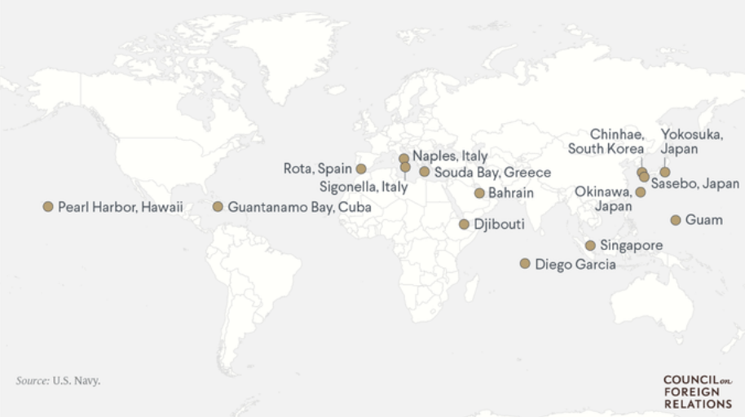

What challenges is the navy facing?
The navy faces headwinds as it plots its course for the next several decades. Leaders are particularly watchful of the western Pacific, where the navy is jockeying with the China for influence. The United States has long dominated the region’s vast waters, but China is pushing hard to gain sway over many of the small island countries with development loans and other inducements. The sparsely populated islands are prized not for their commercial potential but for their strategic value, analysts say.
“This is a pre-conflict type of shadow game, a geopolitical non-war version of island-hopping. The Pacific has become strategic again for the first time since World War II,” international security expert Euan Graham told the Financial Times. The rivalry could intensify as China modernizes its navy, building new aircraft carriers, submarines, and frigates.

Meanwhile, China and many other coastal states are claiming controversial maritime rights—like requiring foreign ships to notify a country before sailing through its territorial waters—that if left unchecked could erode the navy’s access. China is also building artificial islands in the South China Sea.

Jonathon Masters, August 19, 2019
https://www.cfr.org/backgrounder/sea-power-us-navy-and-foreign-policy

