Values and Limitations of Documents / Sources

When asked to discuss the values and limitations of documents you must do this! The examiner needs to see you can critically evaluate a document (e.g. identify strengths and weaknesses, the reliability of a document. The reliability of sources evaluates whether they are trustworthy. It is important that the sources you use in your assessments are reliable so that the quotes you use from them can be trusted.
In history, it is rare that we are completely sure that sources are 100% reliable. Therefore, when we talk about reliability of sources, we can talk in terms of ‘degrees of reliability':

Extremely - Very – Somewhat – Rarely – Not very

For example, we can say that a source is "extremely reliable", or "not very reliable".

Reasons to justify a source’s reliability
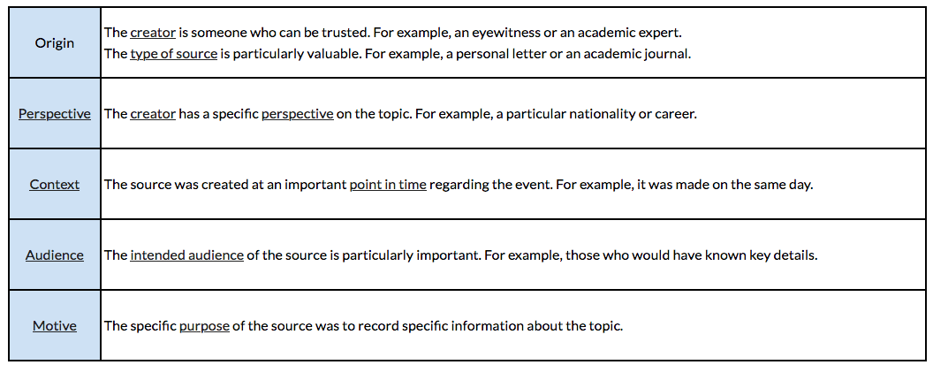
How to establish unreliability of a source

Based upon what you discovered in your analysis of the source, you can establish its unreliability based upon any of the following:

- The creator of the source was not present at the time of the event.

- The creator of the source does not have a sufficiently educated perspective on the topic. (e.g. they have no formal education in History)

- The source has not been fact-checked by an educated audience. (e.g. it is a online blog post)

- The purpose of the source was to be entertaining or to simply give an opinion, rather than focus on the facts, about the topic.

