Reminder about Methodology

AMQs (Annotated Map Questions) require you to draw an annotated map (croquis) and create an organized key or legend, and then using your map, a document and your knowledge to write a 2 page response (short – essay) to a prompt.

You must produce a neat and easy to read annotated map (use coloured pencils and a few felt-tip pens - avoid ballpoint pens and markers and never use highlighters).

Between 10-15 symbols should be used in the legend (ideally 12).

The Information in the legend must be hierarchically categorized (through use of colour and size of symbols) using all four types of representation (areas, lines, arrows, points). Places and names must also be correctly labelled on the map.

Finally, you will need to use your map, together with your knowledge from lessons and a document to write a 2 page response to a prompt.

Guidance for how to construct an Annotated Map
An annotated map ALWAYS includes: | Methods | Principles
A title | Clear and underlined | In History, it has to contain a date  In HG, it has to indicate the space concerned
A scale | Written on the blank map
An orientation | An arrow indicating the direction of the North | On an angle of the map
A legend / key | Organized into several parts | NEVER write the legend on the back of your paper, NEVER above your map  The legend is always written on the right of the symbol, or on a side page
Symbols | Several categories of symbols:  areas, lines, arrows, points | Use a ruler for shapes and lines
An annotated map must to be NEAT, and use regular drawing tools (NO highlighter, NO glitter)

Guidance for creating an Annotated Map Key or Legend
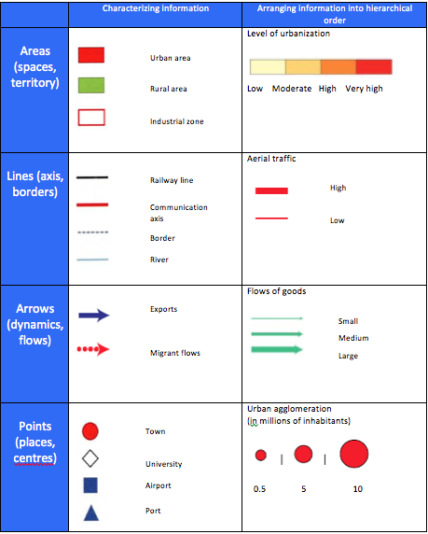
There are 4 basic types of symbols to include on your map in order to represent information:

Areas (e.g. state at the heart of globalization)

Lines (e.g. a communication route)

Arrows (e.g. merchandise flows)

Points (e.g. the location of a city)

