Methodology Booklet

History-Geography
American Section
St Denis International School
OIB

Updated: Oct 2021
History-Geography OIB

The skills you will develop in studying History-Geography are a combination of Bloom’s Taxonomy for learning objectives together with History-Geography specific criteria:

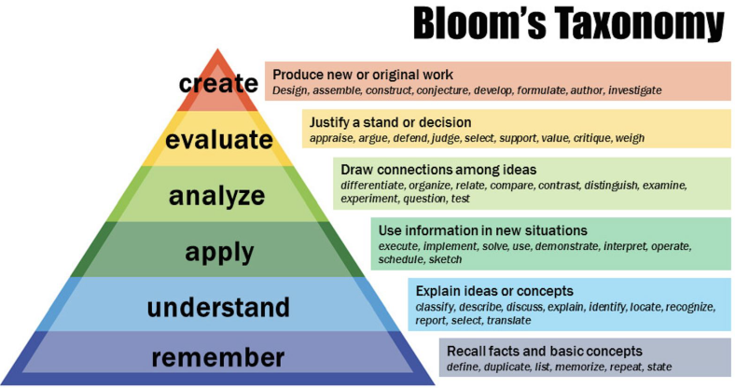

Historical thinking, reading, writing, and speaking skills

● ability to communicate and analyze historical developments and processes using
appropriate and relevant key terms
● ability to analyze documents critically by assessing their value & limitations
● ability to contextualize a historical document in a specific period
● ability to identify an author's perspective, purpose, bias, and audience in a
given document
● ability to compose a thesis statement in an essay
● ability to integrate documents into an essay to address a specific question
● ability to formulate a clearly organized written or oral argument selecting
relevant knowledge and evidence in response to a question
● ability to demonstrate the breadth of historical studies orally
● ability to make comparisons across time and space
● ability to explain historical causation
● ability to differentiate between historical continuity versus change over time
● ability to analyze both political and social history
● ability to categorize the past into discrete periods of time to facilitate analysis
(periodization)
● ability to identify historiographical issues and debates
Geographic analysis, interpretation, writing, and speaking skills

● ability to analyze documents critically by assessing their value & limitations
● ability to identify an author's perspective, purpose, bias, and audience in a
given document
● ability to compose a thesis statement in an essay
● ability to integrate documents into an essay to address a specific question
● ability to formulate a clearly organized written or oral argument selecting
relevant knowledge and evidence in response to a question
● ability to apply geographic language in both written and oral arguments
● ability to carry out multi-scale analysis
● ability to critique the limitations of maps and map keys
● ability to apply an inductive approach from a case study to a general geographic
principle
● ability to analyze processes, patterns and flows
● ability to contextualize a geography document
● ability to relate a document to the geography concepts studied in class

Format of the OIB Exam

The OIB HG exam consists of a single 4-hour written paper in Terminale and a 20 minute oral exam.

This booklet helps you prepare for the oral exam (coefficient 5) and the 4-hour written exam (coefficient 10) which consist of questions in the following format:

Written Exam

Each exam paper will contain Subject A (History Essay and Geography DBQ/AMQ) and Subject B (Geography Essay and History DBQ).

- Essay question (History and Geography subject)
- Data Based Question (either History or Geography subject)
- Annotated Map Question

You must choose one of the two Subjects A or B and complete all of it. Both options contain an essay question which you must complete in 2 hours and leaving two hours to complete the other question.

Oral Exam

The oral exam is divided into two sections: one half about History the other half about Geography. Students will draw a random question from a box and have 20 minutes to prepare a 7 minute presentation in response to the question with 3 minutes of follow-up questions by the examiner. This could be about a Geography or History subject.

For the last 10 minutes of the exam the examiner will then ask the student approximately 10 questions about what the student has learnt in the subject not covered by the presentation.
The exam assesses a student’s speaking and listening skills, and their ability to address the nuances of a question. The oral exam is an exchange between the student and the examiner and the most important part of this exchange is the question and answer session(s).

This booklet provides help on how to approach each of the various types of written questions used in OIB History-Geography exams.

1. Guidance for writing the two-hour essay
You will have to answer one essay question on either a History or Geography subject.

2. Guidance for how to draw an Annotated Map (goes with 3 below)
You may choose to answer the annotated map question in which you construct a map from one of the outline you will have studied in Terminale.

3. Guidance for creating Annotated Map (Croquis) Legends
You will be expected to know how to organize your map legend under different categories to explain the information on your map represented as areas, lines, arrows and points.

4. Further Guidance for answering for drawing the annotated map (croquis) and writing a short essay using the map and a document

5. Guidance for answering Document Based Questions (DBQs)
This explains how to answer a question based on either a History or Geography topic.

1. Guidance for writing the two-hour essay

INTRODUCTION
This is the fundamental part of any History/Geography Essay. It should give context to how you understand the question and states what you will argue in the essay:

- Identifying the period of time/place/area related to the question.

- Defining key terms needed to answer the question.

- The introduction ends with a thesis statement. This is where you state the argument and line of analysis you will develop within each paragraph of the main body of your essay.

ESSAY PARAGRAPHS (main body)
Here you offer historical/geographical evidence that supports what you were saying in the introduction. Each new paragraph should have a mini thesis topic sentence that supports your Thesis Statement. The sentences in the paragraph should then provide evidence, examples, statistics or short quotes to support the paragraph's topic sentence. Each paragraph should conclude by reminding the reader of the takeaway point of the paragraph. Paragraphs should be linked by transition sentences.

CONCLUSION
The conclusion restates the thesis in response to the question; it summarizes arguments made; and it adds a final thought. This final thought could open to a wider point; it could be an analogy; or a connection to a subsequent period of history or to another geographic area.

Please remember:
Make sure your facts are relevant. The objective is not to regurgitate what you read or learned in class. The aim is to develop an argument with integrated examples in response to the question. American essays typically have shorter paragraphs and you should aim to write about 1 000 words for the two-hour exam essay question. Finally, History essays are always in the past tense and Geography essays are written in the present without using first person personal pronouns (e.g. do not write ‘I’).
Terminology and phrasing

Essay questions in OIB HG are usually in the form of an interrogative statement:

- In what ways…
- What are the differences between…
- To what degree…
- To what extent…
- What are the most important (or significant) factors…

Questions may also contain the following command words:

- Explain…
- Explain why…
- Assess…
- Compare and contrast…

2.Guidance for the Annotated Map Question

An annotated map ALWAYS includes: | Methods | Principles
A title | Clear and underlined | In History, it has to contain a date  In HG, it has to indicate the space concerned
A scale | Written on the blank map
An orientation | An arrow indicating the direction of the North | On an angle of the map
A legend / key | Organized into several parts | NEVER write the legend on the back of your paper, NEVER above your map  The legend is always written on the right of the symbol, or on a side page
Symbols | Several categories of symbols:  areas, lines, arrows, points | Use a ruler for shapes and lines
An annotated map must to be NEAT, and use regular drawing tools (NO highlighter, NO glitter)

3. Guidance for creating Annotated Map (Croquis) Legends

 | Characterizing information | Arranging information into hierarchical order
Areas (spaces, territory) | Urban area  Rural area  Industrial zone | Level of urbanization  Low Moderate High Very high
Lines (axis, borders) | Railway line  Communication axis  Border  River | Aerial traffic  High  Low
Arrows (dynamics, flows) | Exports  Migrant flows | Flows of goods  Small  Medium  Large
Points (places, centres) | Town  University  Airport  Port | Urban agglomeration  (in millions of inhabitants)  0.5 5 10
4. Drawing the annotated map (croquis) and legend, and using your map, a document and your knowledge to write a 2 page response (essay) to a prompt

You must produce a neat and easy to read annotated map (use coloured pencils and a few felt-tip pens - avoid ballpoint pens and markers and never use highlighters).

Between 10-15 symbols should be used in the legend (ideally 12).

The Information in the legend must be hierarchical categorized (through use of colour and size of symbols) using all four types of representation (areas, lines, arrows, points). Places and names must also be correctly labelled on the map.

Finally, you will need to use your map, together with your knowledge from lessons and a document to write a 2 page response to a prompt.
5. Guidance for answering Document Based Questions (DBQs)

Document based exam questions always include the following instructions:

Using the documents and your own knowledge…. answer the question

and

Discuss the values and limitations of the document in your essay

You must use the document in your answer (e.g. quote pertinent information from it but do not copy it word for word, and use it to inform and develop your response to the question). You must also use your own knowledge from your studies in your response – you cannot rely on only using information from the document.

Critical evaluation of a document

Discuss the values and limitations of the document (or documents) means you must critically evaluate the document:

- comment on the strengths/weakness of a document,
- consider the reliability of a document (e.g. reliability of newspaper accounts, cartoons)
- consider the objectivity/bias of the author

Generally, the closer the information is in time and space to the event itself the more accurate or reliable it should be. However, you should keep in mind:

* Who is the author?
* Why was it recorded?
* When was it recorded?
* What is it?

Eyewitness accounts are the most obvious primary sources of information, but they can be selective, inaccurate, limited and undetailed. Personal experience accounts are often invaluable but don’t necessarily contain much factual information.

Factors that affect the reliability of a document:

Bias/Prejudice – occurs when one point of view is favoured over other points of view.
Propaganda – using half-truths or lies to convince the receiver of a certain point of view
Subjectivity (subjective) – occurs when one person’s viewpoint is given, reflects an emotional input
Exaggeration – adding additional fictitious details – bigger/smaller, better/worse
Cross-checks – have the details been verified through another source

Evaluating cartoons

Cartoons are useful to historians when trying to understand how people or events in the past were viewed by contemporary observers.

* They give insight into mood and attitude at the time, however
* Cartoonists are not interested in a balanced view
* They rely heavily on caricature and exaggeration to make their points
* They assume the viewer has a certain amount of background knowledge in order to understand the image

Evaluating Maps

Consider the title of the map and what it purports to show. Think about who or what organization produced it, where and when. Maps can be very useful but they may be overly complicated or overly simplified. The legend may be poorly organized and certain characteristics may be represented in an unusual way in order to emphasize a feature (e.g. anamorphic maps).

You must comment on the organization of the legend and think how have symbols, points, flows and areas been subdivided underneath different headings.

Please remember: You are evaluating the usefulness of a document in answering the question being presented.

About 25% of a DBQ essay should be about document analysis. This means you must discuss the document: ‘It is useful because…’ or ‘there are limitations because’, or ‘these voices are not heard in the document which means that…’ are some simple ways to incorporate this analysis though more sophisticated candidates will be able to integrate the analysis throughout their essay.

